

***Our Savior Lutheran Church***

Seventeenth Sunday After Pentecost

October 2, 2022

912 Christ Is Our Cornerstone

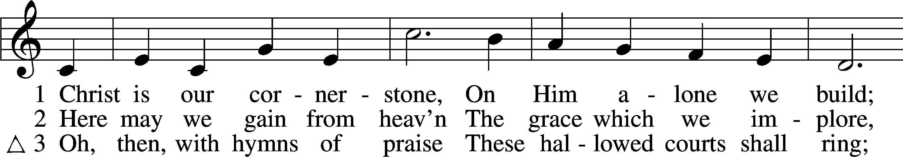

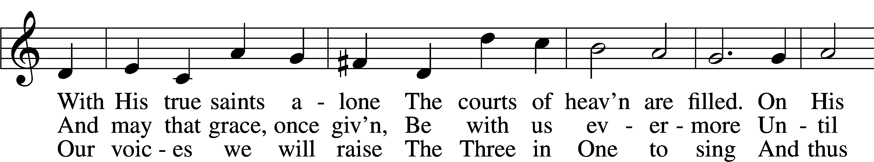

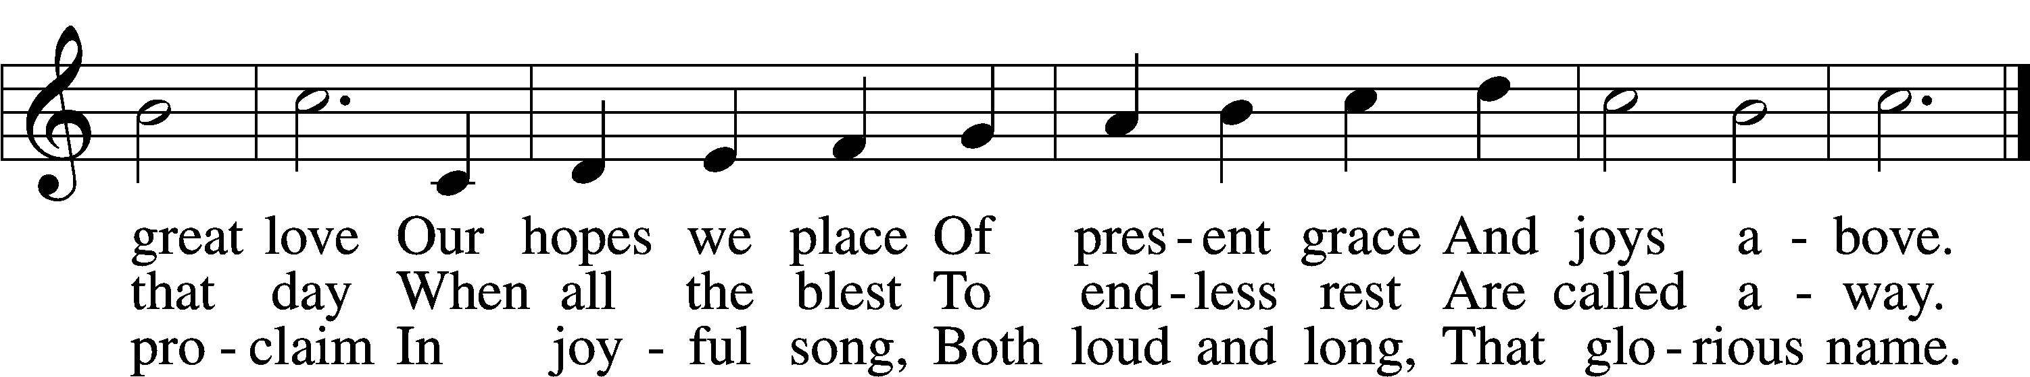

Text: Latin, c. 8th cent.; tr. John Chandler, 1806–76, alt.  
Tune: John Darwall, 1731–89  
Text and tune: Public domain

Stand

The sign of the cross may be made by all in remembrance of their Baptism.

P In the name of the Father and of the T Son and of the Holy Spirit.

C **Amen.**

P Our help is in the name of the Lord,

C **who made heaven and earth.**

P If You, O Lord, kept a record of sins, O Lord, who could stand?

C **But with You there is forgiveness; therefore You are feared.**

P Since we are gathered to hear God’s Word, call upon Him in prayer and praise, and receive the body and blood of our Lord Jesus Christ in the fellowship of this altar, let us first consider our unworthiness and confess before God and one another that we have sinned in thought, word, and deed, and that we cannot free ourselves from our sinful condition. Together as His people let us take refuge in the infinite mercy of God, our heavenly Father, seeking His grace for the sake of Christ, and saying: God, be merciful to me, a sinner.

Kneel/Stand

C **Almighty God, have mercy upon us, forgive us our sins, and lead us to everlasting life. Amen.**

P Almighty God, merciful Father, in Holy Baptism You declared us to be Your children and gathered us into Your one, holy Church, in which You daily and richly forgive us our sins and grant us new life through Your Spirit. Be in our midst, enliven our faith, and graciously receive our prayer and praise; through Your Son, Jesus Christ, our Lord.

C **Amen.**

Stand

# Service of the Word

Introit Psalm 119:162, 164–165, 167; antiphon: v. 166

P: I hope for your salvation, O Lord, and I do your commandments.

**C: I rejoice at your word like one who finds great spoil.**

P: Seven times a day Ipraise you for your just and righteous decrees.

**C: Great peace have those who love your law; nothing can make them stumble.**

P: My soul keeps your testimonies; I love them exceedingly.

**All: Glory be to the Father and to the Son and to the Holy Spirit; as it was in the beginning, is now, and will be forever. Amen.**

P: I hope for your salvation,O Lord, and I do your commandments.

Kyrie LSB 204

C **Lord, have mercy;**

**Christ, have mercy;**

**Lord, have mercy.**

Gloria in Excelsis LSB 204

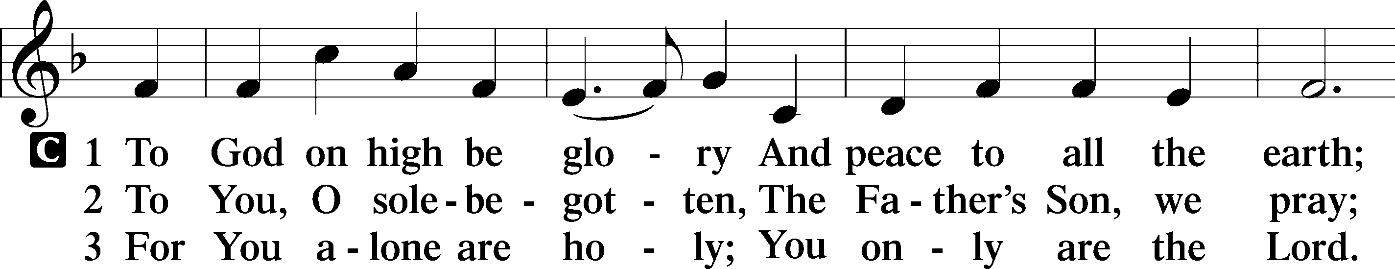

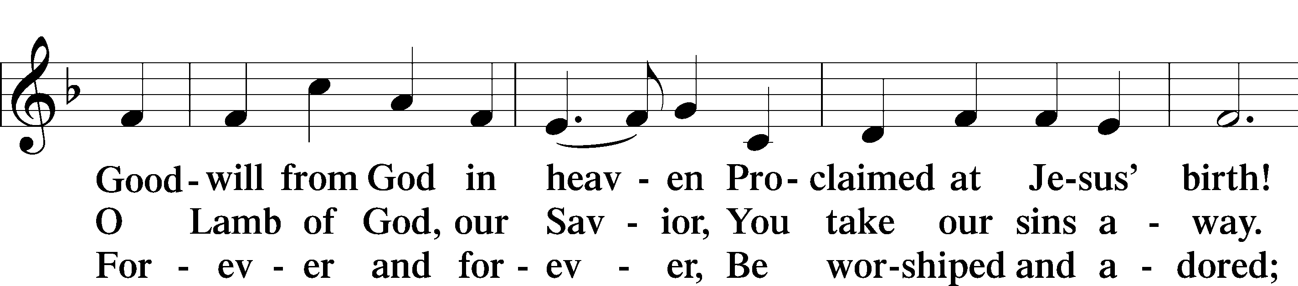

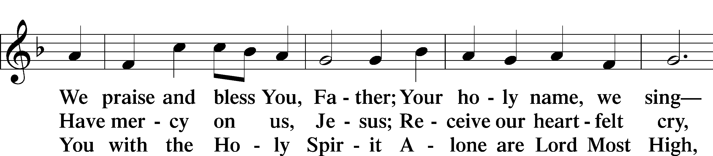

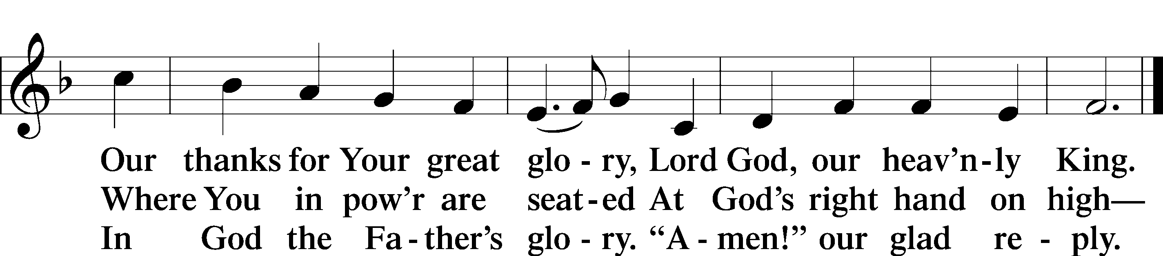

Text: Stephen P. Starke

Salutation and Collect of the Day

P The Lord be with you.

C **And also with you.**

P Let us pray.

O God, our refuge and strength, the author of all godliness, by Your grace hear the prayers of Your Church. Grant that those things which we ask in faith we may receive through Your bountiful mercy; through Jesus Christ, Your Son, our Lord, who lives and reigns with You and the Holy Spirit, one God, now and forever.

C **Amen.**

Sit

First Reading Acts 20:7–12

7On the first day of the week, when we were gathered together to break bread, Paul talked with them, intending to depart on the next day, and he prolonged his speech until midnight. 8There were many lamps in the upper room where we were gathered. 9And a young man named Eutychus, sitting at the window, sank into a deep sleep as Paul talked still longer. And being overcome by sleep, he fell down from the third story and was taken up dead. 10But Paul went down and bent over him, and taking him in his arms, said, “Do not be alarmed, for his life is in him.” 11And when Paul had gone up and had broken bread and eaten, he conversed with them a long while, until daybreak, and so departed. 12And they took the youth away alive, and were not a little comforted.

A This is the Word of the Lord.

C **Thanks be to God.**

Children’s Message

Epistle Hebrews 10:18–25

18Where there is forgiveness of these, there is no longer any offering for sin.

19Therefore, brothers, since we have confidence to enter the holy places by the blood of Jesus, 20by the new and living way that he opened for us through the curtain, that is, through his flesh, 21and since we have a great priest over the house of God, 22let us draw near with a true heart in full assurance of faith, with our hearts sprinkled clean from an evil conscience and our bodies washed with pure water. 23Let us hold fast the confession of our hope without wavering, for he who promised is faithful. 24And let us consider how to stir up one another to love and good works, 25not neglecting to meet together, as is the habit of some, but encouraging one another, and all the more as you see the Day drawing near.

A This is the Word of the Lord.

C **Thanks be to God.**

Stand

Alleluia and Verse

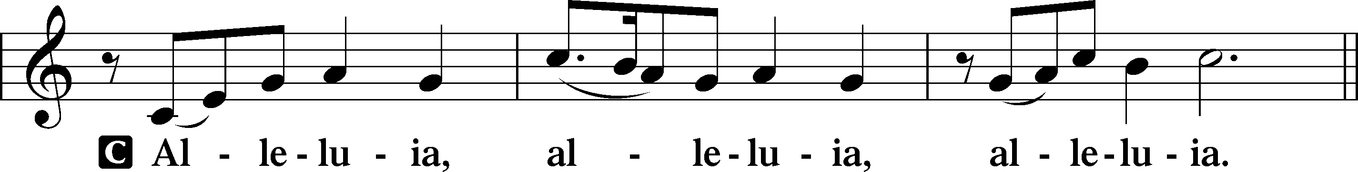

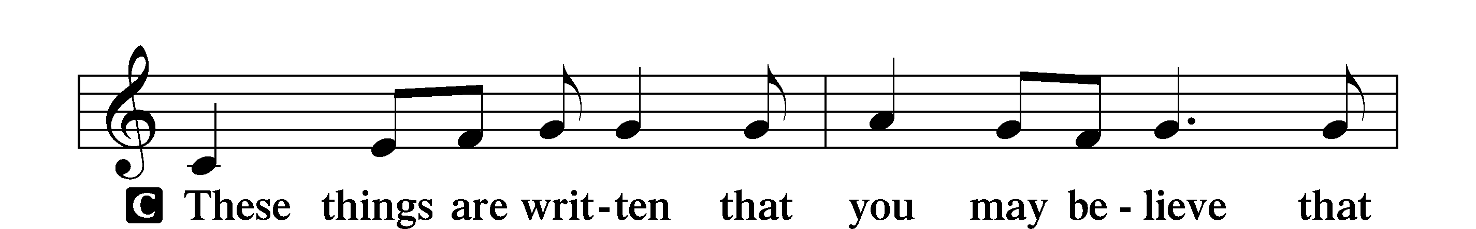

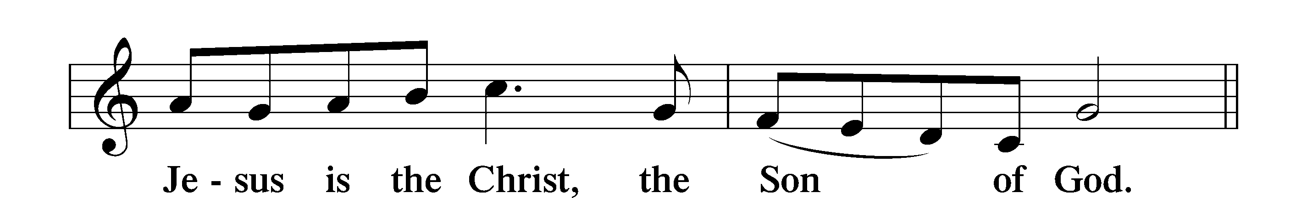

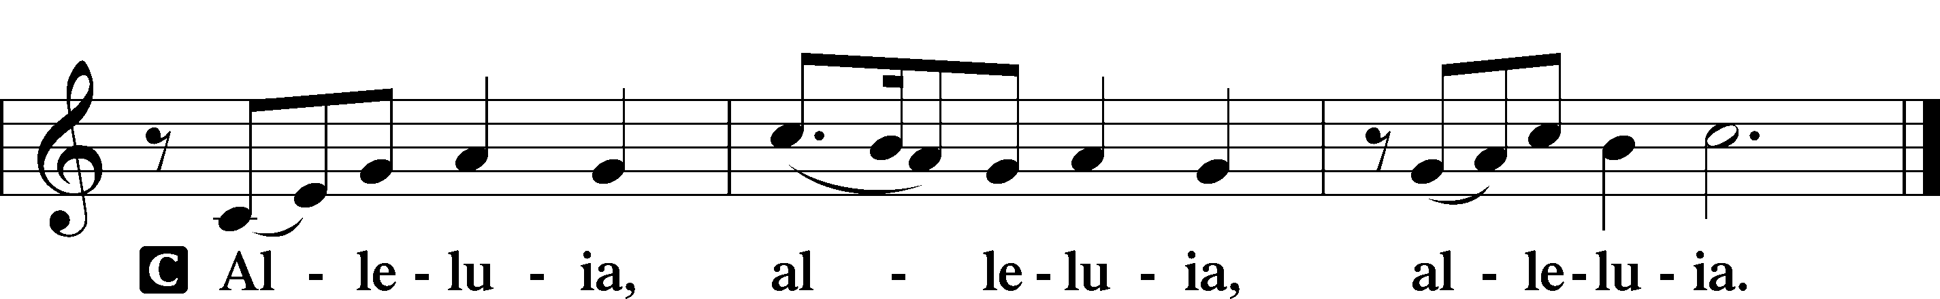

Holy Gospel Matthew 16:13–19

P The Holy Gospel according to St. Matthew, the sixteenth chapter.

C **Glory to You, O Lord.**

13Now when Jesus came into the district of Caesarea Philippi, he asked his disciples, “Who do people say that the Son of Man is?” 14And they said, “Some say John the Baptist, others say Elijah, and others Jeremiah or one of the prophets.” 15He said to them, “But who do you say that I am?” 16Simon Peter replied, “You are the Christ, the Son of the living God.” 17And Jesus answered him, “Blessed are you, Simon Bar-Jonah! For flesh and blood has not revealed this to you, but my Father who is in heaven. 18And I tell you, you are Peter, and on this rock I will build my church, and the gates of hell shall not prevail against it. 19I will give you the keys of the kingdom of heaven, and whatever you bind on earth shall be bound in heaven, and whatever you loose on earth shall be loosed in heaven.”

P This is the Gospel of the Lord.

C **Praise to You, O Christ.**

Apostles’ Creed

C **I believe in God, the Father Almighty,**

**maker of heaven and earth.**

**And in Jesus Christ, His only Son, our Lord,**

**who was conceived by the Holy Spirit,**

**born of the virgin Mary,**

**suffered under Pontius Pilate,**

**was crucified, died and was buried.**

**He descended into hell.**

**The third day He rose again from the dead.**

**He ascended into heaven**

**and sits at the right hand of God the Father Almighty.**

**From thence He will come to judge the living and the dead.**

**I believe in the Holy Spirit,**

**the holy Christian Church,**

**the communion of saints,**

**the forgiveness of sins,**

**the resurrection of the body,**

**and the life** T **everlasting. Amen.**

Sit

644 The Church’s One Foundation sts. 1–5

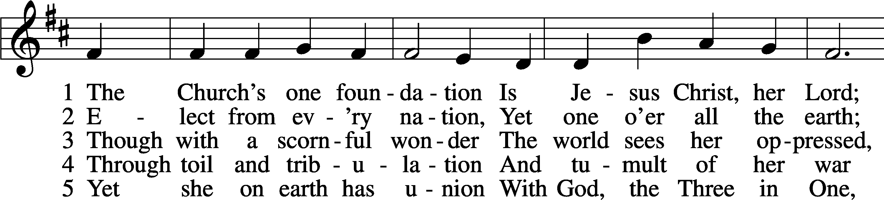

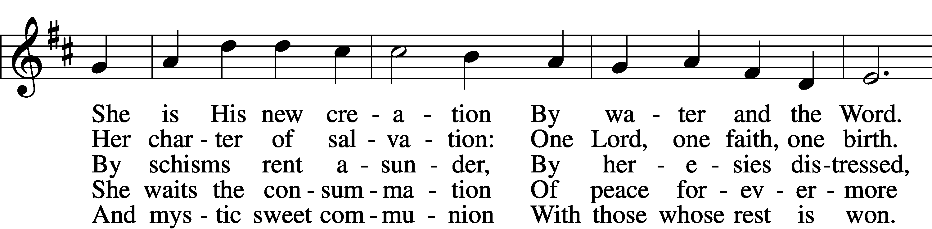

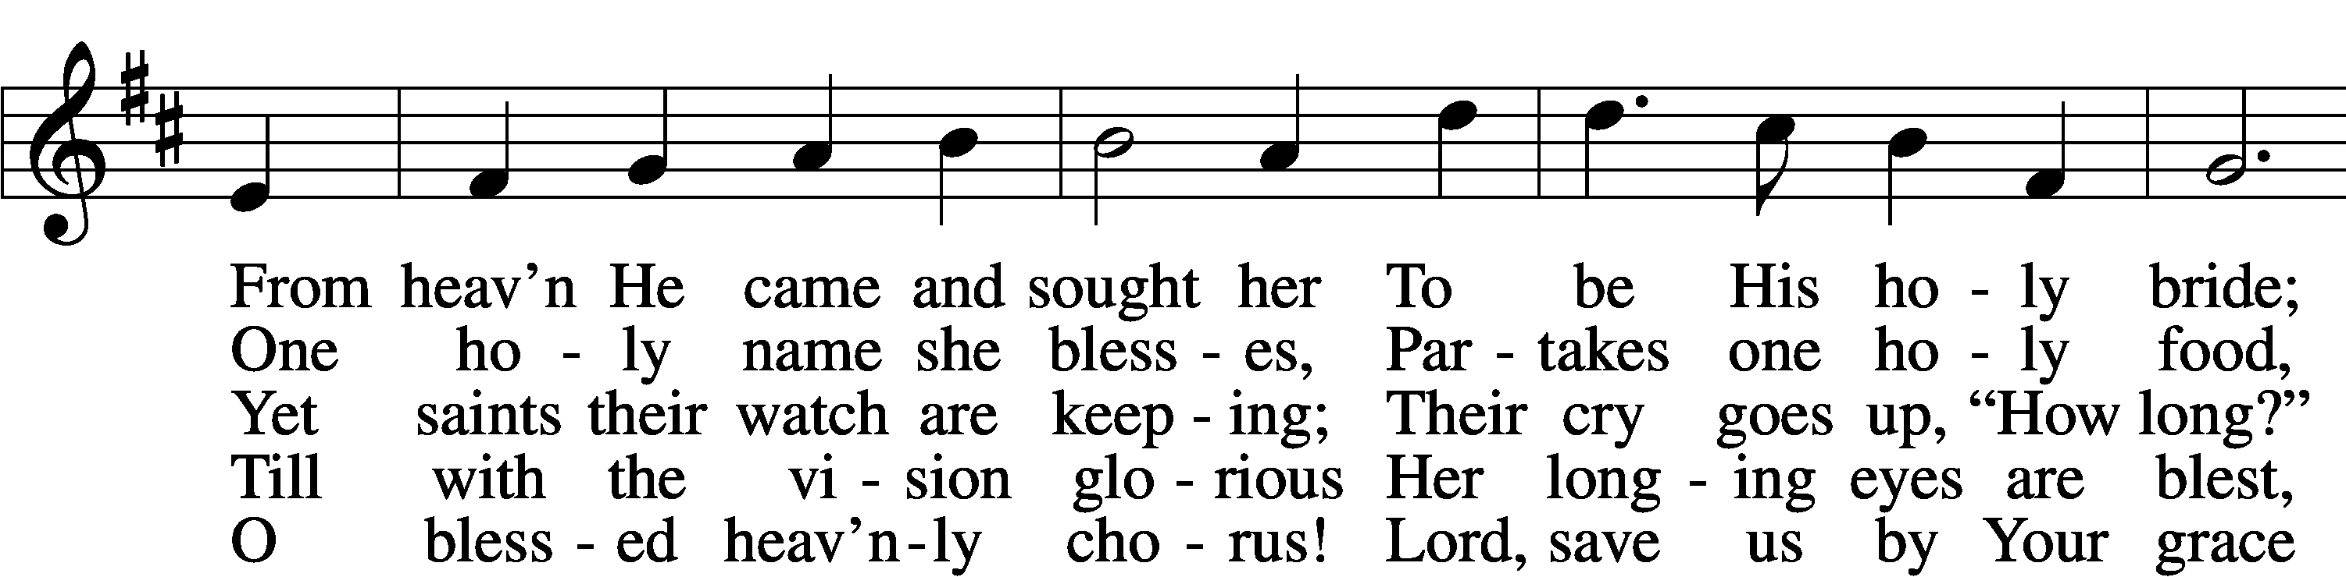

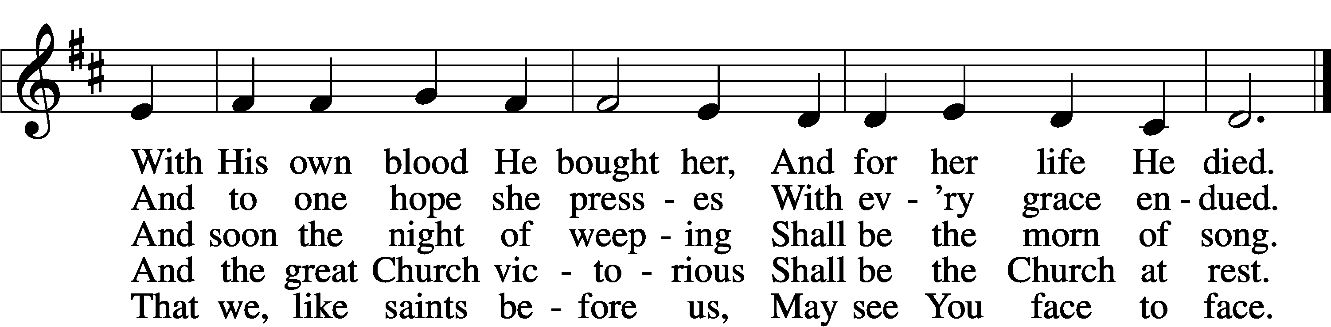

Text: Samuel J. Stone, 1839–1900, alt.  
Tune: Samuel S. Wesley, 1810–76  
Text and tune: Public domain

Sermon

Offering

Stand

Prayer of the Church

Lord’s Prayer

C **Our Father who art in heaven, hallowed be Thy name, Thy kingdom come,**

**Thy will be done on earth as it is in heaven; give us this day our daily bread;**

**and forgive us our trespasses as we forgive those who trespass against us;**

**and lead us not into temptation, but deliver us from evil. For Thine is the kingdom and the power and the glory forever and ever. Amen.**

Sit

Benediction

P The Lord bless you and keep you.

The Lord make His face shine on you and be gracious to you.

The Lord look upon you with favor and T give you peace.

C **Amen.**

670 Ye Watchers and Ye Holy Ones

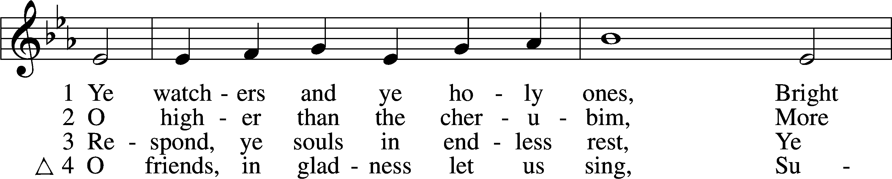

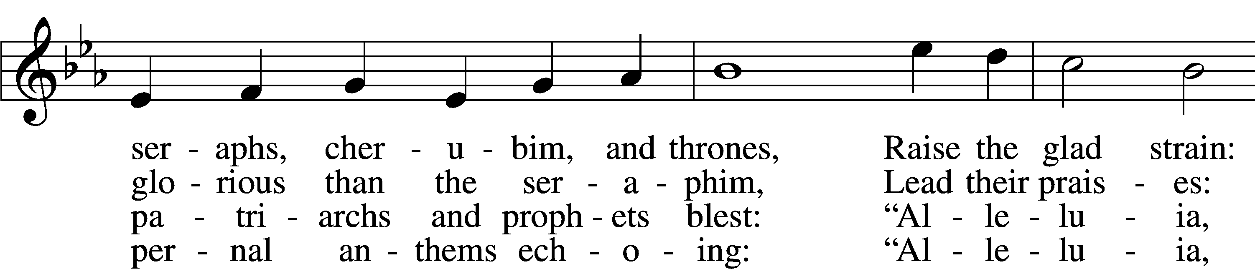

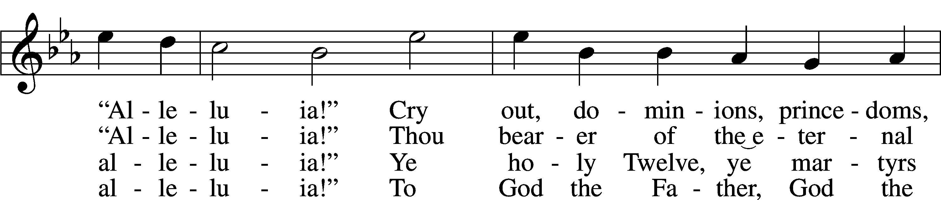

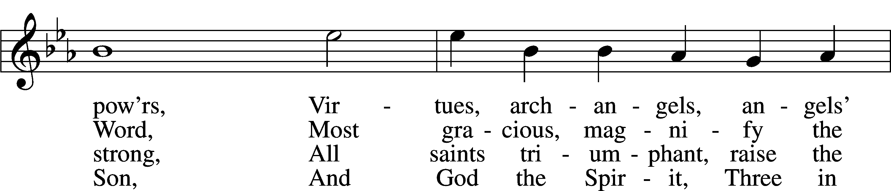

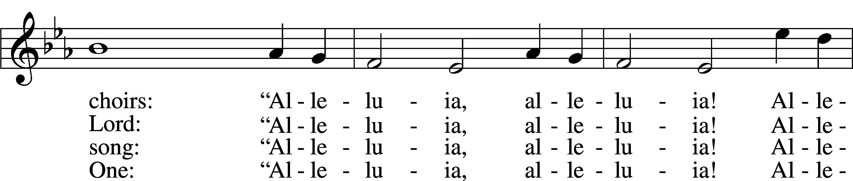

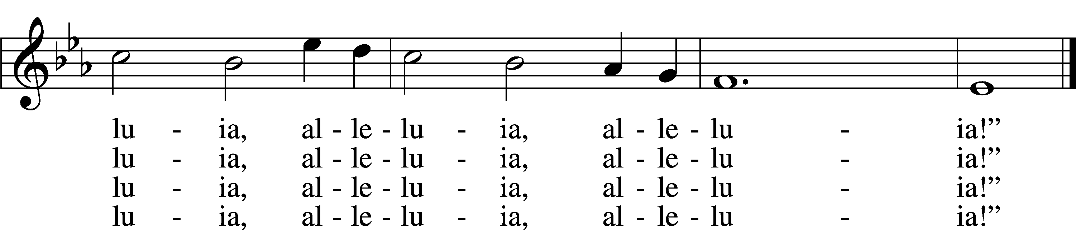

Text: J. Athelstan L. Riley, 1858–1945, alt.  
Tune: Geistliche Kirchengesäng, 1623, Köln  
Text and tune: Public domain

Acknowledgments

Divine Service, Setting Four from Lutheran Service Book

Unless otherwise indicated, Scripture quotations are from the ESV® Bible (The Holy Bible, English Standard Version®), copyright © 2001 by Crossway, a publishing ministry of Good News Publishers. Used by permission. All rights reserved.

Created by Lutheran Service Builder © 2022 Concordia Publishing House.

**PRAYERS**

Jori Sutton (Daughter of Schuyler & Kirby hospitalized w/ RSV)

Renee Bartlett, Allen Bures, Jay Chapin, Gail Custer,

Joyce Custer, Donna Davis, David Dawson,

Delbert Grefe, Charlie Heidbrink, Jamie Hennerberg,

Sheri Hibbert, Kandi Ingram, Dorothy Lindquist, Jaydin Maguire, Mary Lou Meeriam, Darlene Menniga, Jim Meyer,

Rhonda Meyer, Deb Minge, Stan Ohlde, Karen Oldehoeft,

Phyllis O’Toole, Dan Rash, Kaleb Rupprecht, Rick Samland, Dorothy Scheele, Merlin Scheele, Deb Scheideler, June Snyder,

Kristina Snyder, Troy Stauffer, Pastor Tim Wagner,

Gene Weilage, Loretta Williams, Doyle Wolken,

Amy Wrightsman, Tony Young

*(Loved ones are kept on the prayer list unless otherwise requested)*

**Pray for our Military:** Active Duty: Frank Lanagan, stationed in Washington; Liam Blum, stationed in Japan

**Calendar of Events**

Sun. 10/02 9:00 am Divine Service

10:00 am Sunday School/Adult Bible Study

Mon. 10/3 New Member Class at 6:30

Chosen Series Video/Bible Study 7pm

Wed 10/05 Mid-week 3:45-5:30

Our Savior Youth Lead 6pm

Choir at 7:30

Sun. 10/09 9:00 am Divine Service w/Communion

10:00 am Sunday School/Adult Bible Study

**Worship Assistants for Sunday, October 2nd**

**Greeters:** Earl Adam

**Reader:** Andy Adam **Acolyte:** Hannah

**Lead Youth Ushers:** Preston

**Worship Assistants for Sunday, October 9th**

**Greeters:** Kathy & Lorna Adam

**Reader:** Gary Bures **Acolyte:** Brooklyn

**Lead Youth Usher:** Dylan

**Celebrating the Generosity of God’s Children by God’s Grace**

Throughout the month of October, we will be recognizing the blessings that God has bestowed on us for over 96 years.

On October 2 2022 we are remembering the years of 1926-1946.

On October 9 2022 we are remembering the years of 1946-1966.

We remember those who were led by God to start a congregation in Odell, NE named

Our Savior Lutheran Church

**ANNOUNCEMENTS**

New member classes continue to be on Mondays @ 6:30 pm.

Mid-Week classes continue with 7th & 8th grade confirmation @ 3:45 pm and 1st -6th grades @ 4: 30 pm.

LWML Fall Rally will be held on Sunday, October 2nd @

First Trinity Lutheran Church, Beatrice. Registration is from 12:00- 12:30 pm. Lunch served @ 12:30 pm with the meeting, Bible Study, election of officers, etc. Members are asked to bring items for the Willow Tree Pregnancy Center. These include diapers size #5 & #6; pullups size 2/3 T & size 4/5 T; wipes.

They assemble birthday bags for the clients of their children. They could use cake mixes, frosting, paper plates, napkins, & birthday candles. Thanks!

Choir Practice at 7:30 on Wednesdays

Thank you for the Children who enriched our service with music

Grace Lutheran in Fairbury is planning a trip to Mission Central in Mapleton IA on Saturday, October 15th. They are leaving Fairbury at 6am and loading in Beatrice at Walmart between 6:30 – 6:45am. The cost is $50 / person. The hope is to get the tour bus filled. Please let Pastor Emery know today if possible.

Pastor Emery’s # is 402-729-5163