

Our Savior Lutheran

**Last Sunday in the Church Year**

November 20th, 2022

902 Lord Jesus Christ, Be Present Now

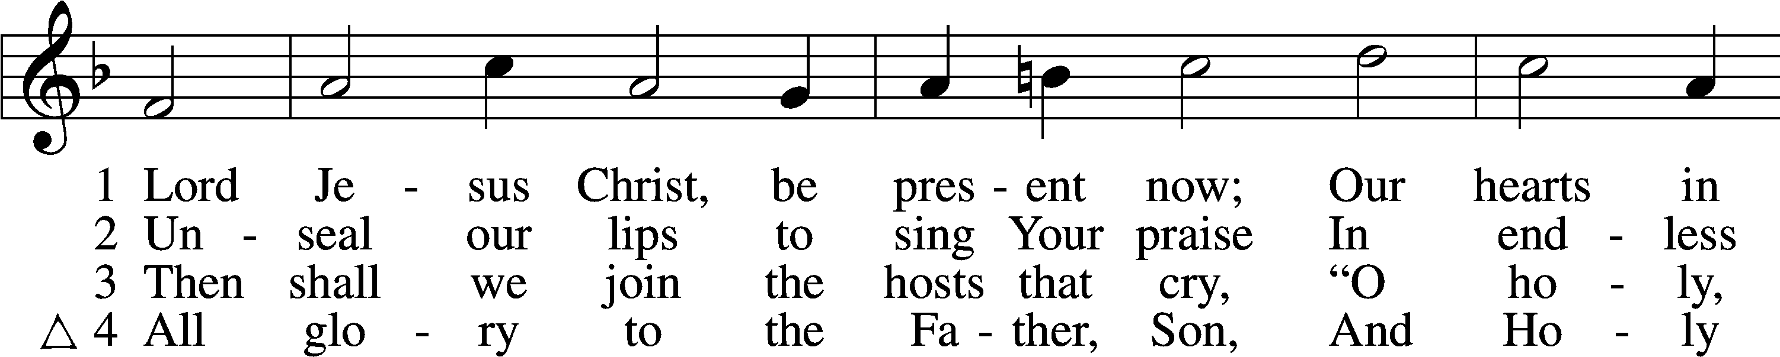

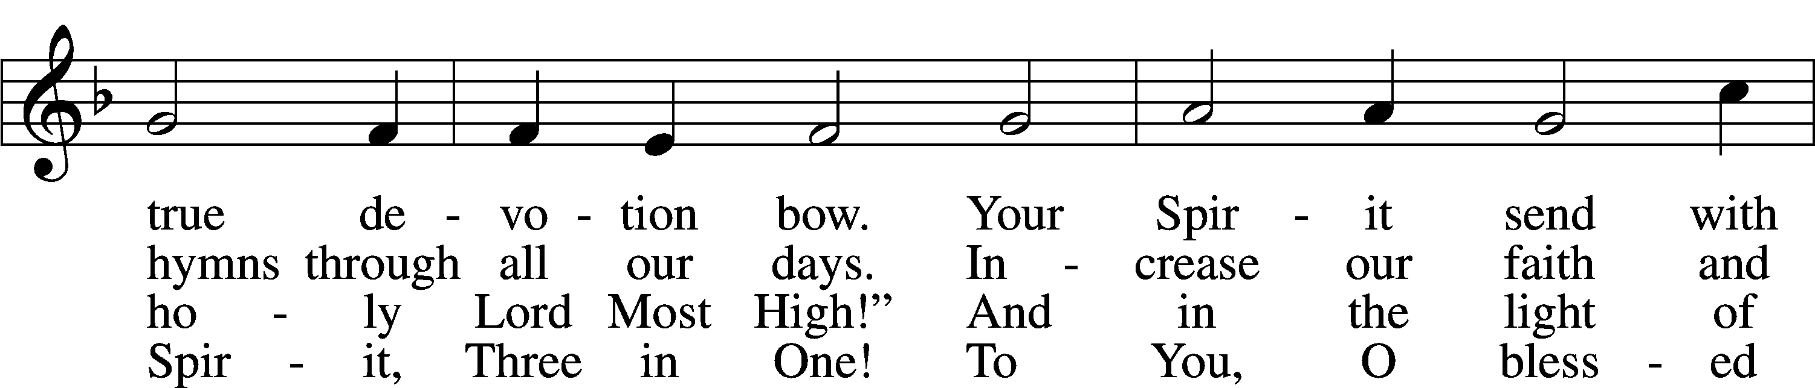

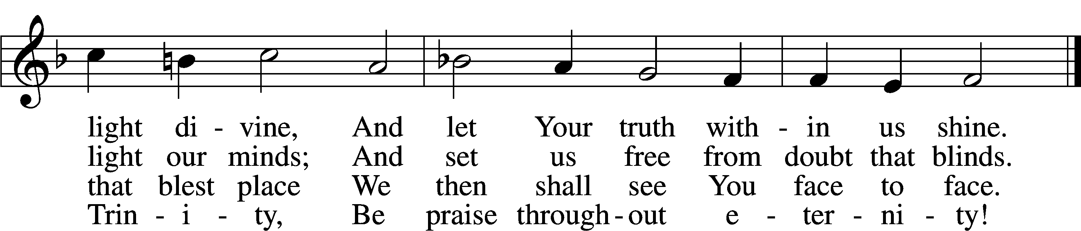

Text: Lutherisch Hand-Büchlein, 1648, Altenburg; tr. Catherine Winkworth, 1827–78, alt.Tune: Cantionale Germanicum, 1628, GochsheimText and tune: Public domain

Stand

The sign of the cross may be made by all in remembrance of their Baptism.

P In the name of the Father and of the T Son and of the Holy Spirit.

C **Amen.**

P Our help is in the name of the Lord,

C **who made heaven and earth.**

P If You, O Lord, kept a record of sins, O Lord, who could stand?

C **But with You there is forgiveness; therefore You are feared.**

P Since we are gathered to hear God’s Word, call upon Him in prayer and praise, and receive the body and blood of our Lord Jesus Christ in the fellowship of this altar, let us first consider our unworthiness and confess before God and one another that we have sinned in thought, word, and deed, and that we cannot free ourselves from our sinful condition. Together as His people let us take refuge in the infinite mercy of God, our heavenly Father, seeking His grace for the sake of Christ, and saying: God, be merciful to me, a sinner.

Kneel/Stand

C **Almighty God, have mercy upon us, forgive us our sins, and lead us to everlasting life. Amen.**

P Almighty God, merciful Father, in Holy Baptism You declared us to be Your children and gathered us into Your one, holy Church, in which You daily and richly forgive us our sins and grant us new life through Your Spirit. Be in our midst, enliven our faith, and graciously receive our prayer and praise; through Your Son, Jesus Christ, our Lord.

C **Amen.**

Stand

# Service of the Word

Introit Psalm 134; antiphon: Psalm 33:8

P: Let all the earth fear the Lord; let all the inhabitants of the world stand inawe of him!

**C: Come, bless the Lord, all you servants of the Lord, who stand by night in the house of the Lord!**

P: Lift up your hands to theholy place andbless the Lord!

**C: May the Lord bless you from Zion, he who made heaven and earth!**

**All: Glory be to the Father and to the Son and to the Holy Spirit; as it was in the beginning, is now, and will be forever. Amen.**

P: Let all the earthfear the Lord; let all the inhabitants of the world stand inawe of him!

Kyrie LSB 204

C **Lord, have mercy;**

**Christ, have mercy;**

**Lord, have mercy.**

Gloria in Excelsis LSB 204

C **1 To God on high be glory**

**And peace to all the earth;**

**Goodwill from God in heaven**

**Proclaimed at Jesus’ birth!**

**We praise and bless You, Father;**

**Your holy name, we sing—**

**Our thanks for Your great glory,**

**Lord God, our heav’nly King.**

**2 To You, O sole-begotten,**

**The Father’s Son, we pray;**

**O Lamb of God, our Savior,**

**You take our sins away.**

**Have mercy on us, Jesus;**

**Receive our heartfelt cry,**

**Where You in pow’r are seated**

**At God’s right hand on high—**

**3 For You alone are holy;**

**You only are the Lord.**

**Forever and forever,**

**Be worshiped and adored;**

**You with the Holy Spirit**

**Alone are Lord Most High,**

**In God the Father’s glory.**

**“Amen!” our glad reply.**

Text: Stephen P. Starke

Salutation and Collect of the Day

P The Lord be with you.

C **And also with you.**

P Let us pray.

Lord Jesus Christ, You reign among us by the preaching of Your cross. Forgive Your people their offenses that we, being governed by Your bountiful goodness, may enter at last into Your eternal paradise; for You live and reign with the Father and the Holy Spirit, one God, now and forever.

C **Amen.**

Sit

Old Testament Reading Malachi 3:13–18

13“Your words have been hard against me, says the Lord. But you say, ‘How have we spoken against you?’ 14You have said, ‘It is vain to serve God. What is the profit of our keeping his charge or of walking as in mourning before the Lord of hosts? 15And now we call the arrogant blessed. Evildoers not only prosper but they put God to the test and they escape.’”

16Then those who feared the Lord spoke with one another. The Lord paid attention and heard them, and a book of remembrance was written before him of those who feared the Lord and esteemed his name. 17“They shall be mine, says the Lord of hosts, in the day when I make up my treasured possession, and I will spare them as a man spares his son who serves him. 18Then once more you shall see the distinction between the righteous and the wicked, between one who serves God and one who does not serve him.”

A This is the Word of the Lord.

C **Thanks be to God.**

Children’s Message

Epistle Colossians 1:13–20

13He has delivered us from the domain of darkness and transferred us to the kingdom of his beloved Son, 14in whom we have redemption, the forgiveness of sins.

15He is the image of the invisible God, the firstborn of all creation. 16For by him all things were created, in heaven and on earth, visible and invisible, whether thrones or dominions or rulers or authorities—all things were created through him and for him. 17And he is before all things, and in him all things hold together. 18And he is the head of the body, the church. He is the beginning, the firstborn from the dead, that in everything he might be preeminent. 19For in him all the fullness of God was pleased to dwell, 20and through him to reconcile to himself all things, whether on earth or in heaven, making peace by the blood of his cross.

A This is the Word of the Lord.

C **Thanks be to God.**

Stand

Alleluia and Verse

C **Alleluia, alleluia, alleluia.**

C **These things are written that you may believe that Jesus is the Christ, the Son of God.**

C **Alleluia, alleluia, alleluia.**

Holy Gospel Luke 23:27–43

P The Holy Gospel according to St. Luke, the twenty-third chapter.

C **Glory to You, O Lord.**

27And there followed [Jesus] a great multitude of the people and of women who were mourning and lamenting for him. 28But turning to them Jesus said, “Daughters of Jerusalem, do not weep for me, but weep for yourselves and for your children. 29For behold, the days are coming when they will say, ‘Blessed are the barren and the wombs that never bore and the breasts that never nursed!’ 30Then they will begin to say to the mountains, ‘Fall on us,’ and to the hills, ‘Cover us.’ 31For if they do these things when the wood is green, what will happen when it is dry?”

32Two others, who were criminals, were led away to be put to death with him. 33And when they came to the place that is called The Skull, there they crucified him, and the criminals, one on his right and one on his left. 34And Jesus said, “Father, forgive them, for they know not what they do.” And they cast lots to divide his garments. 35And the people stood by, watching, but the rulers scoffed at him, saying, “He saved others; let him save himself, if he is the Christ of God, his Chosen One!” 36The soldiers also mocked him, coming up and offering him sour wine 37and saying, “If you are the King of the Jews, save yourself!” 38There was also an inscription over him, “This is the King of the Jews.”

39One of the criminals who were hanged railed at him, saying, “Are you not the Christ? Save yourself and us!” 40But the other rebuked him, saying, “Do you not fear God, since you are under the same sentence of condemnation? 41And we indeed justly, for we are receiving the due reward of our deeds; but this man has done nothing wrong.” 42And he said, “Jesus, remember me when you come into your kingdom.” 43And he said to him, “Truly, I say to you, today you will be with me in Paradise.”

P This is the Gospel of the Lord.

C **Praise to You, O Christ.**

Apostles’ Creed

C **I believe in God, the Father Almighty, maker of heaven and earth.**

**And in Jesus Christ, His only Son, our Lord, who was conceived by the Holy Spirit, born of the virgin Mary, suffered under Pontius Pilate, was crucified, died and was buried. He descended into hell. The third day He rose again from the dead. He ascended into heaven and sits at the right hand of God the Father Almighty. From thence He will come to judge the living and the dead.**

**I believe in the Holy Spirit, the holy Christian Church, the communion of saints, the forgiveness of sins, the resurrection of the body, and the life** T **everlasting. Amen.**

Sit

435 Come to Calvary’s Holy Mountain

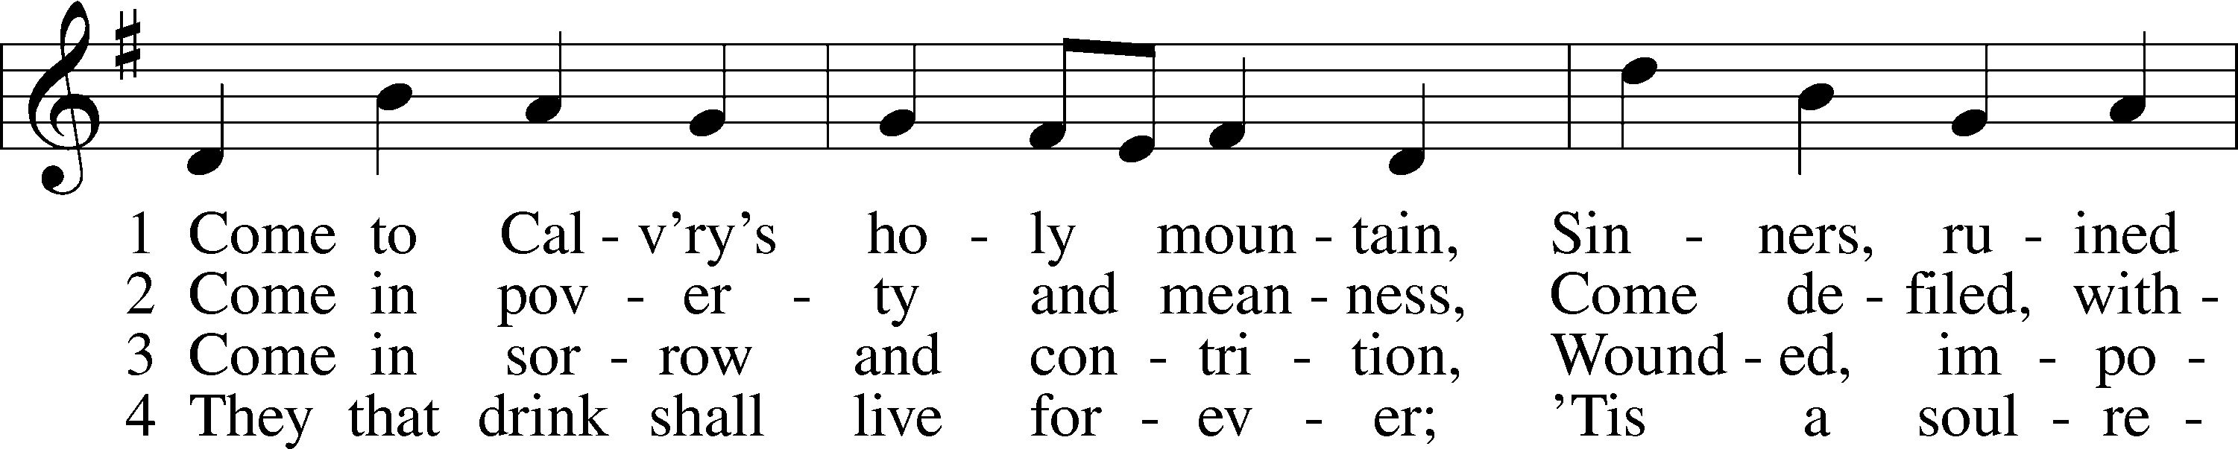

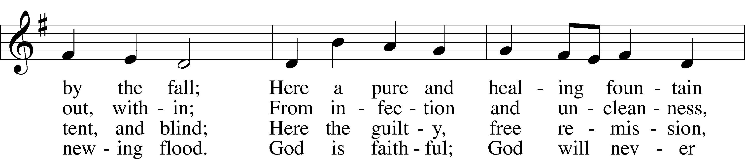

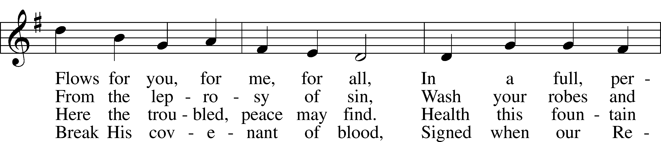

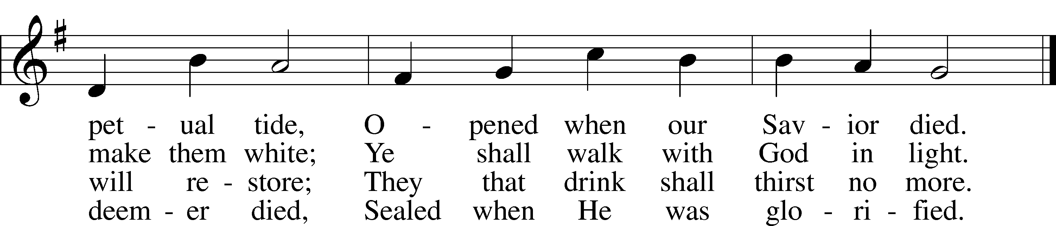

Text: James Montgomery, 1771–1854, alt.  
Tune: Ludvig M. Lindeman, 1812–87 Text and tune: Public domain

Sermon

Sit

Offering

Stand

Prayer of the Church/Lord’s Prayer

Benediction

P The Lord bless you and keep you.

The Lord make His face shine on you and be gracious to you.

The Lord look upon you with favor and T give you peace.

C **Amen.**

525 Crown Him with Many Crowns

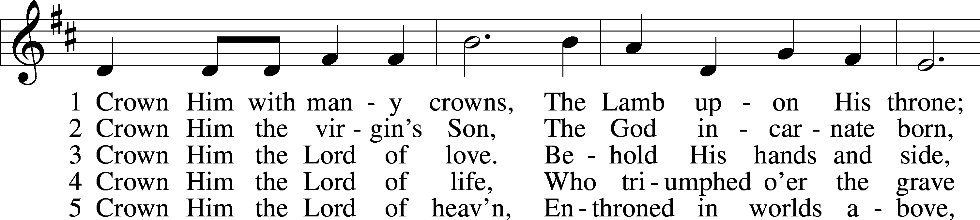

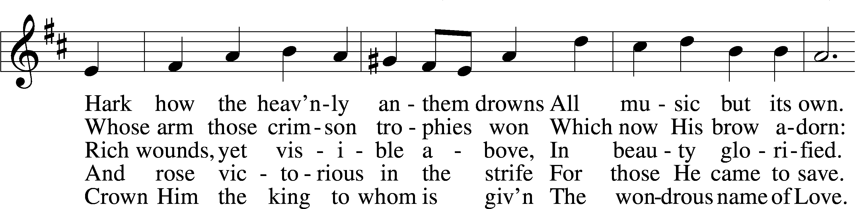

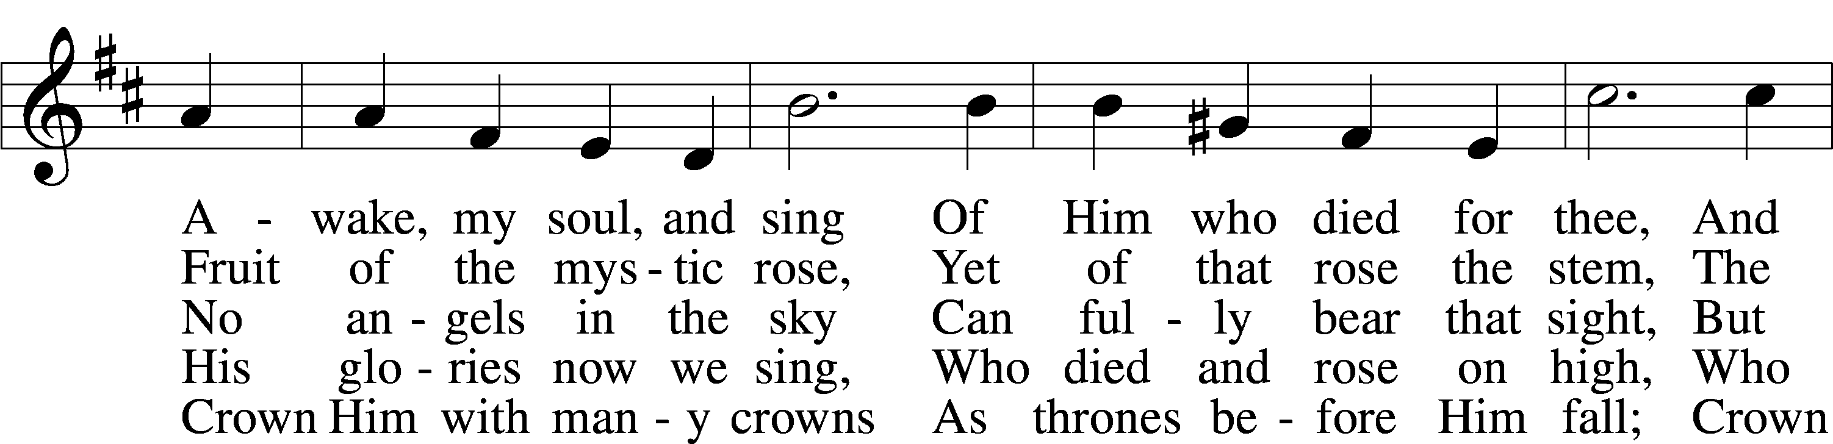

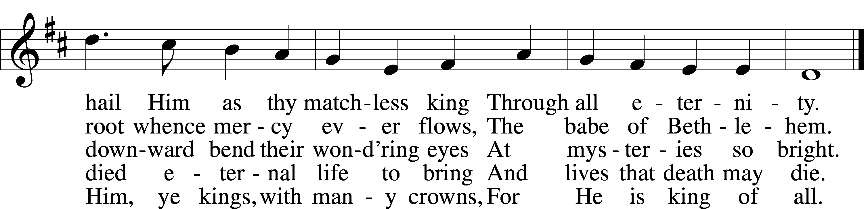

Text (sts. 1–3, 5): Matthew Bridges, 1800–94, alt.; (st. 4): Godfrey Thring, 1823–1903 Tune: George J. Elvey, 1816–93 Text and tune: Public domain

Acknowledgments

Divine Service, Setting Four from Lutheran Service Book

Unless otherwise indicated, Scripture quotations are from the ESV® Bible (The Holy Bible, English Standard Version®), copyright © 2001 by Crossway, a publishing ministry of Good News Publishers. Used by permission. All rights reserved.

Created by Lutheran Service Builder © 2022 Concordia Publishing House.

**PRAYERS**

The family of Adam Helmerichs

Delbert Bartels, Renee Bartlett, Allen Bures, Jay Chapin,

Gail Custer, Joyce Custer, Donna Davis, David Dawson,

Delbert Grefe, Charlie Heidbrink, Jamie Hennerberg,

Sheri Hibbert, Terry Imig, Kandi Ingram, Toni Landenberger, Dorothy Lindquist, Jaydin Maguire, Mary Lou Meeriam,

Darlene Menniga, Jim Meyer, Rhonda Meyer, Father Joe Miksch, Deb Minge, Stan Ohlde, Karen Oldehoeft, Phyllis O’Toole,

Dan Rash, Kaleb Rupprecht, Rick Samland, Dave Scharff,

Dorothy Scheele, Merlin Scheele, Deb Scheideler,

June Snyder, Kristina Snyder, Troy Stauffer, Janet Stuckwisch, Pastor Tim Wagner, Gene Weilage, Loretta Williams,

Tyler Wolken, Amy Wrightsman, Tony Young

*(Loved ones are kept on the prayer list unless otherwise requested)*

**Pray for our Military:** Active Duty: Frank Lanagan, stationed in Washington; Liam Blum, stationed in Japan

**Birthdays:** Deagan Andersen (11/20); Kasen Kotas (11/21);

Ashley Rees (11/23); Anthony Landon (11/25)

**Baptismal Birthdays:** Mary Jo Bures, Bernice Vitosh (11/20); Collins Mynatt (11/21); Alexis Collins (11/22);

Linsey Freitag (11/26)

**Anniversaries:**

##### **Calendar of Events**

Sun. 11/20 9:00 am Divine Service

10:00 am Bible Study/Christmas Program Practice

Wed. 11/23 No MidWeek

**7:00 pm Thanksgiving Eve Service**

No Choir Practice

Sat. 11/26 Odell Craft Fair & Food Booths

Sun. 11/27 9:00 am Divine Service w/communion

10;00 am Bible Study/Christmas Program Practice

**_____________________________________________________**

**Worship Assistants for Sunday, November 20th**

**Greeters:** Ron & Cathy Bures

**Reader:** Paul Kostal **Acolyte:** Anna

**Lead Youth Usher:** Noah

**Worship Assistants for Sunday, November 23rd**

**Greeters:** Janice Duntz

**Reader:** Steve Kostal **Acolyte:** Hannah

**Lead Youth Usher:** Maddie R.

**Worship Assistants for Sunday, November 27th**

**Greeters:** Kevin & DeAnna Duis

**Reader:** Steve Manley **Acolyte:** Brooklyn

**Lead Youth Usher:** Kailyn

______________________________________________________________________________________

**ANNOUNCEMENTS**

Last Chosen I Bible Study is Monday, November 21st @ 7pm.

Mercy Meals Packing Event on Monday, November 28th.

Poster in back with details.

Advent Services will begin on Wednesday, November 30th @

7:00 pm. A meal will be served before the service. The meal

will begin @ 6:00 pm. Please join us!

Join us on Saturday, December 3rd @ 10:00 am to decorate the

church for Christmas.

St. Paul’s LWML is extending an invitation to all ladies to

join them for a Christmas Tea on Sunday, December 4th @

1:30 pm at the church.

Christmas Caroling: Sunday, December 11th.

All ages welcome for caroling, delivering care packages, and

our meal & gift exchange!

Schedule for the day:

- 2:30 pm - Put care packages together

- 3:00 pm - Caroling on hayrack

- 5:00 pm - Back to church to eat

Gift exchange and games to follow. If you wish to participate

in the gift exchange, bring one $10 item wrapped.

If interested in purchasing a poinsettia to adorn the church this

Christmas season, please let Joyce Kostal know!

The members of Grace Lutheran Church in Fairbury invite

you to join them on a motor coach tour to the Ark Encounter

& Creation Museum, June 3-10, 2023. Details in back on

poster board if interested.