

**The Fifth Sunday**

**in Lent**

Our Savior Lutheran

March 26, 2023

908 Lord, Open Now My Heart to Hear

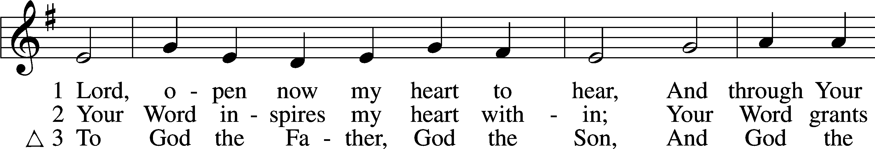

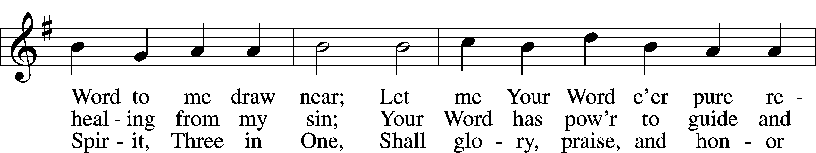

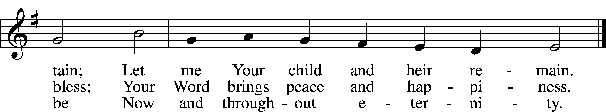

Text: Johann Olearius, 1611–84; (sts. 1, 3): tr. Matthias Loy, 1828–1915, alt.; (st. 2): tr. Mark A. Jeske, 1952  
Tune: Geistliche Lieder auffs new gebessert, 1543, Wittenberg, ed. Joseph Klug  
Text (st. 2): © 1993 Mark A. Jeske. Used by permission: LSB Hymn License no. 110003789  
Text (sts. 1, 3) and tune: Public domain

Stand

The sign of the cross may be made by all in remembrance of their Baptism.

P In the name of the Father and of the T Son and of the Holy Spirit.

C **Amen.**

P Beloved in the Lord! Let us draw near with a true heart and confess our sins unto God our Father, beseeching Him in the name of our Lord Jesus Christ to grant us forgiveness.

P Our help is in the name of the Lord,

C **who made heaven and earth.**

P I said, I will confess my transgressions unto the Lord,

C **and You forgave the iniquity of my sin.**

Kneel/Stand

Silence for reflection on God’s Word and for self-examination.

P O almighty God, merciful Father,

C **I, a poor, miserable sinner, confess unto You all my sins and iniquities with which I have ever offended You and justly deserved Your temporal and eternal punishment. But I am heartily sorry for them and sincerely repent of them, and I pray You of Your boundless mercy and for the sake of the holy, innocent, bitter sufferings and death of Your beloved Son, Jesus Christ, to be gracious and merciful to me, a poor, sinful being.**

P Upon this your confession, I, by virtue of my office, as a called and ordained servant of the Word, announce the grace of God unto all of you, and in the stead and by the command of my Lord Jesus Christ I forgive you all your sins in the name of the Father and of the T Son and of the Holy Spirit.

C **Amen.**

Stand

# Service of the Word

Introit Psalm 116:1–4, 8; antiphon: v. 15

P: Precious in the sight of the Lord is the death of his saints.

**C: I love the Lord, because he has heard my voice and my pleas for mercy.**

P: Because he inclined his ear to me, therefore I will call on him as long as I live.

**C: The snares of death encompassed me; the pangs of Sheol laid hold on me; I suffered distress and anguish.**

P: Then I called on the name of the Lord: "O Lord, I pray, deliver my soul!"

**C: For you have delivered my soul from death, my eyes from tears, my feet from stumbling.**

**All: Glory be to the Father and to the Son and to the Holy Spirit; as it was in the beginning, is now, and will be forever.**  **Amen.**

P: Precious in the sight of the Lord is the death of his saints.

C **Glory be to the Father and to the Son and to the Holy Ghost;**

**as it was in the beginning, is now, and ever shall be, world without end. Amen.**

Kyrie LSB 186

C **Lord, have mercy upon us.**

**Christ, have mercy upon us.**

**Lord, have mercy upon us.**

Salutation and Collect of the Day

P The Lord be with you.

C **And with thy spirit.**

P Let us pray.

Almighty God, by Your great goodness mercifully look upon Your people that we may be governed and preserved evermore in body and soul; through Jesus Christ, Your Son, our Lord, who lives and reigns with You and the Holy Spirit, one God, now and forever.

C **Amen.**

Sit

Old Testament Reading Ezekiel 37:1–14

1The hand of the Lord was upon me, and he brought me out in the Spirit of the Lord and set me down in the middle of the valley; it was full of bones. 2And he led me around among them, and behold, there were very many on the surface of the valley, and behold, they were very dry. 3And he said to me, “Son of man, can these bones live?” And I answered, “O Lord God, you know.” 4Then he said to me, “Prophesy over these bones, and say to them, O dry bones, hear the word of the Lord. 5Thus says the Lord God to these bones: Behold, I will cause breath to enter you, and you shall live. 6And I will lay sinews upon you, and will cause flesh to come upon you, and cover you with skin, and put breath in you, and you shall live, and you shall know that I am the Lord.”

7So I prophesied as I was commanded. And as I prophesied, there was a sound, and behold, a rattling, and the bones came together, bone to its bone. 8And I looked, and behold, there were sinews on them, and flesh had come upon them, and skin had covered them. But there was no breath in them. 9Then he said to me, “Prophesy to the breath; prophesy, son of man, and say to the breath, Thus says the Lord God: Come from the four winds, O breath, and breathe on these slain, that they may live.” 10So I prophesied as he commanded me, and the breath came into them, and they lived and stood on their feet, an exceedingly great army.

11Then he said to me, “Son of man, these bones are the whole house of Israel. Behold, they say, ‘Our bones are dried up, and our hope is lost; we are clean cut off.’ 12Therefore prophesy, and say to them, Thus says the Lord God: Behold, I will open your graves and raise you from your graves, O my people. And I will bring you into the land of Israel. 13And you shall know that I am the Lord, when I open your graves, and raise you from your graves, O my people. 14And I will put my Spirit within you, and you shall live, and I will place you in your own land. Then you shall know that I am the Lord; I have spoken, and I will do it, declares the Lord.”

A This is the Word of the Lord.

C **Thanks be to God.**

Children’s Message

Epistle Romans 8:1–11

1There is therefore now no condemnation for those who are in Christ Jesus. 2For the law of the Spirit of life has set you free in Christ Jesus from the law of sin and death. 3For God has done what the law, weakened by the flesh, could not do. By sending his own Son in the likeness of sinful flesh and for sin, he condemned sin in the flesh, 4in order that the righteous requirement of the law might be fulfilled in us, who walk not according to the flesh but according to the Spirit. 5For those who live according to the flesh set their minds on the things of the flesh, but those who live according to the Spirit set their minds on the things of the Spirit. 6To set the mind on the flesh is death, but to set the mind on the Spirit is life and peace. 7For the mind that is set on the flesh is hostile to God, for it does not submit to God’s law; indeed, it cannot. 8Those who are in the flesh cannot please God.

9You, however, are not in the flesh but in the Spirit, if in fact the Spirit of God dwells in you. Anyone who does not have the Spirit of Christ does not belong to him. 10But if Christ is in you, although the body is dead because of sin, the Spirit is life because of righteousness. 11If the Spirit of him who raised Jesus from the dead dwells in you, he who raised Christ Jesus from the dead will also give life to your mortal bodies through his Spirit who dwells in you.

A This is the Word of the Lord.

C **Thanks be to God.**

Stand

Holy Gospel John 11:1–45

P The Holy Gospel according to St. John, the eleventh chapter.

C **Glory be to Thee, O Lord.**

1Now a certain man was ill, Lazarus of Bethany, the village of Mary and her sister Martha. 2It was Mary who anointed the Lord with ointment and wiped his feet with her hair, whose brother Lazarus was ill. 3So the sisters sent to him, saying, “Lord, he whom you love is ill.” 4But when Jesus heard it he said, “This illness does not lead to death. It is for the glory of God, so that the Son of God may be glorified through it.”

5Now Jesus loved Martha and her sister and Lazarus. 6So, when he heard that Lazarus was ill, he stayed two days longer in the place where he was. 7Then after this he said to the disciples, “Let us go to Judea again.” 8The disciples said to him, “Rabbi, the Jews were just now seeking to stone you, and are you going there again?” 9Jesus answered, “Are there not twelve hours in the day? If anyone walks in the day, he does not stumble, because he sees the light of this world. 10But if anyone walks in the night, he stumbles, because the light is not in him.” 11After saying these things, he said to them, “Our friend Lazarus has fallen asleep, but I go to awaken him.” 12The disciples said to him, “Lord, if he has fallen asleep, he will recover.” 13Now Jesus had spoken of his death, but they thought that he meant taking rest in sleep. 14Then Jesus told them plainly, “Lazarus has died, 15and for your sake I am glad that I was not there, so that you may believe. But let us go to him.” 16So Thomas, called the Twin, said to his fellow disciples, “Let us also go, that we may die with him.”

17Now when Jesus came, he found that Lazarus had already been in the tomb four days. 18Bethany was near Jerusalem, about two miles off, 19and many of the Jews had come to Martha and Mary to console them concerning their brother. 20So when Martha heard that Jesus was coming, she went and met him, but Mary remained seated in the house. 21Martha said to Jesus, “Lord, if you had been here, my brother would not have died. 22But even now I know that whatever you ask from God, God will give you.” 23Jesus said to her, “Your brother will rise again.” 24Martha said to him, “I know that he will rise again in the resurrection on the last day.” 25Jesus said to her, “I am the resurrection and the life. Whoever believes in me, though he die, yet shall he live, 26and everyone who lives and believes in me shall never die. Do you believe this?” 27She said to him, “Yes, Lord; I believe that you are the Christ, the Son of God, who is coming into the world.”

28When she had said this, she went and called her sister Mary, saying in private, “The Teacher is here and is calling for you.” 29And when she heard it, she rose quickly and went to him. 30Now Jesus had not yet come into the village, but was still in the place where Martha had met him. 31When the Jews who were with her in the house, consoling her, saw Mary rise quickly and go out, they followed her, supposing that she was going to the tomb to weep there. 32Now when Mary came to where Jesus was and saw him, she fell at his feet, saying to him, “Lord, if you had been here, my brother would not have died.” 33When Jesus saw her weeping, and the Jews who had come with her also weeping, he was deeply moved in his spirit and greatly troubled. 34And he said, “Where have you laid him?” They said to him, “Lord, come and see.” 35Jesus wept. 36So the Jews said, “See how he loved him!” 37But some of them said, “Could not he who opened the eyes of the blind man also have kept this man from dying?”

38Then Jesus, deeply moved again, came to the tomb. It was a cave, and a stone lay against it. 39Jesus said, “Take away the stone.” Martha, the sister of the dead man, said to him, “Lord, by this time there will be an odor, for he has been dead four days.” 40Jesus said to her, “Did I not tell you that if you believed you would see the glory of God?” 41So they took away the stone. And Jesus lifted up his eyes and said, “Father, I thank you that you have heard me. 42I knew that you always hear me, but I said this on account of the people standing around, that they may believe that you sent me.” 43When he had said these things, he cried out with a loud voice, “Lazarus, come out.” 44The man who had died came out, his hands and feet bound with linen strips, and his face wrapped with a cloth. Jesus said to them, “Unbind him, and let him go.”

45Many of the Jews therefore, who had come with Mary and had seen what he did, believed in him.

P This is the Gospel of the Lord.

C **Praise be to Thee, O Christ.**

Nicene Creed

C **I believe in one God,**

**the Father Almighty,**

**maker of heaven and earth**

**and of all things visible and invisible.**

**And in one Lord Jesus Christ,**

**the only-begotten Son of God,**

**begotten of His Father before all worlds,**

**God of God, Light of Light,**

**very God of very God,**

**begotten, not made,**

**being of one substance with the Father,**

**by whom all things were made;**

**who for us men and for our salvation came down from heaven**

**and was incarnate by the Holy Spirit of the virgin Mary**

**and was made man;**

**and was crucified also for us under Pontius Pilate.**

**He suffered and was buried.**

**And the third day He rose again according to the Scriptures**

**and ascended into heaven**

**and sits at the right hand of the Father.**

**And He will come again with glory to judge both the living and the dead,**

**whose kingdom will have no end.**

**And I believe in the Holy Spirit,**

**the Lord and giver of life,**

**who proceeds from the Father and the Son,**

**who with the Father and the Son together is worshiped and glorified,**

**who spoke by the prophets.**

**And I believe in one holy Christian and apostolic Church,**

**I acknowledge one Baptism for the remission of sins,**

**and I look for the resurrection of the dead**

**and the life** T **of the world to come. Amen.**

Sit

771 Be Still, My Soul, before the Lord

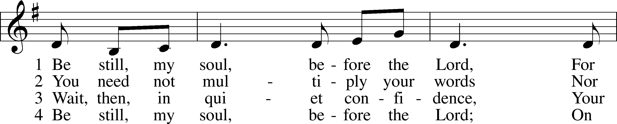

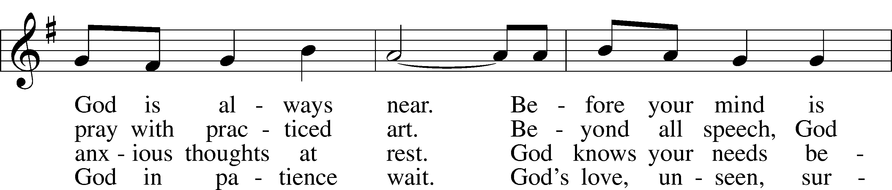

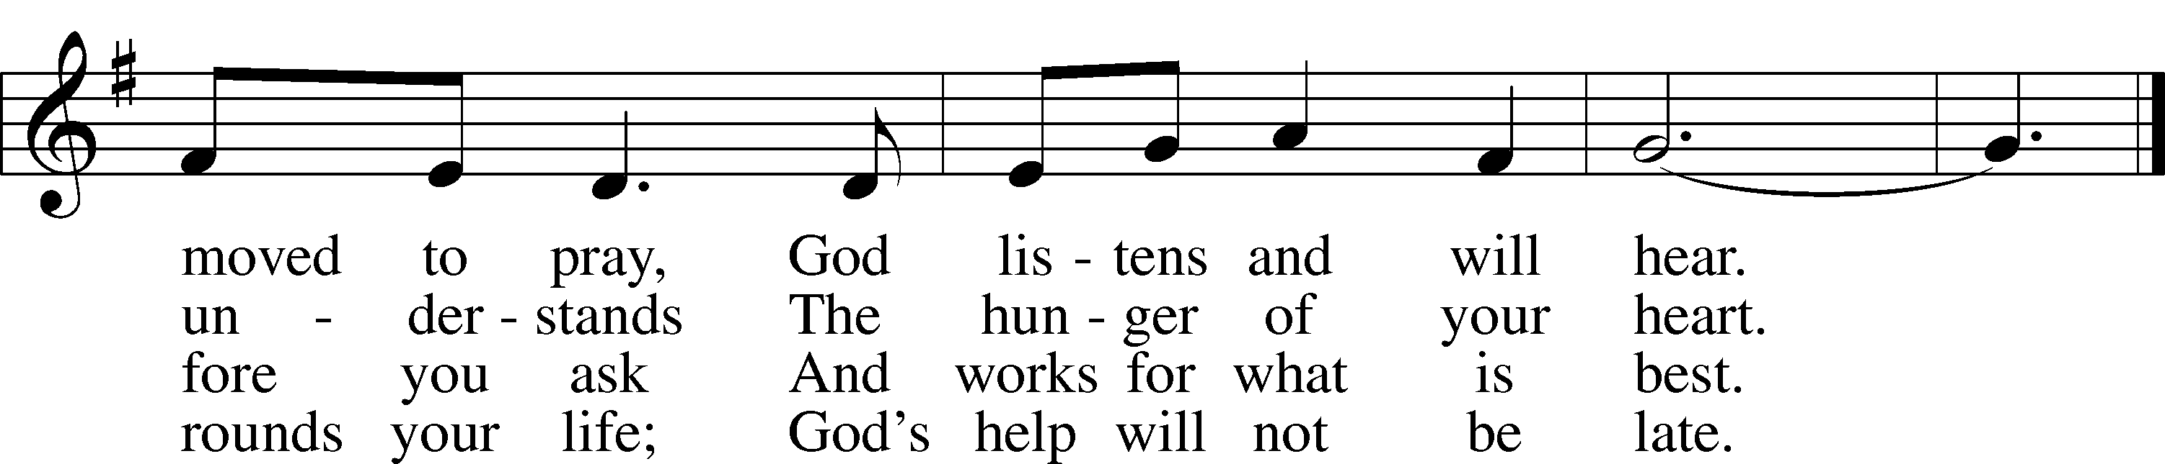

Text: Herman G. Stuempfle, Jr., 1923–2007  
Tune: Marty Haugen, 1950  
Text: © 2000 GIA Publications, Inc. Used by permission: LSB Hymn License no. 110003789  
Tune: © 1984, 2006 GIA Publications, Inc. Used by permission: LSB Hymn License no. 110003789

Sermon

P The peace of God, which passes all understanding, keep your hearts and minds in Christ Jesus.

C **Amen.**

Stand

Offertory LSB 192

C **Create in me a clean heart, O God, and renew a right spirit within me.**

**Cast me not away from Thy presence, and take not Thy Holy Spirit from me.**

**Restore unto me the joy of Thy salvation, and uphold me with Thy free spirit. Amen.**

Sit

Offering

Stand

Prayer of the Church

# Service of the Sacrament

Preface LSB 194

P The Lord be with you.

C **And with thy spirit.**

P Lift up your hearts.

C **We lift them up unto the Lord.**

P Let us give thanks unto the Lord, our God.

C **It is meet and right so to do.**

P It is truly meet, right, and salutary that we should at all times and in all places give thanks to You, holy Lord, almighty Father, everlasting God, through Jesus Christ, our Lord, who overcame the assaults of the devil and gave His life as a ransom for many that with cleansed hearts we might be prepared joyfully to celebrate the paschal feast in sincerity and truth. Therefore with angels and archangels and with all the company of heaven we laud and magnify Your glorious name, evermore praising You and saying:

Sanctus LSB 195

C **Holy, holy, holy Lord God of Sabaoth;**

**heav’n and earth are full of Thy glory.**

**Hosanna, hosanna, hosanna in the highest.**

**Blessed is He, blessed is He, blessed is He that cometh in the name of the Lord.**

**Hosanna, hosanna, hosanna in the highest.**

Lord’s Prayer LSB 196

P Our Father who art in heaven,

hallowed be Thy name,

Thy kingdom come,

Thy will be done on earth as it is in heaven;

give us this day our daily bread;

and forgive us our trespasses as we forgive those who trespass against us;

and lead us not into temptation,

but deliver us from evil.

C **For Thine is the kingdom and the power and the glory forever and ever. Amen.**

The Words of Our Lord LSB 197

P Our Lord Jesus Christ, on the night when He was betrayed, took bread, and when He had given thanks, He broke it and gave it to the disciples and said: “Take, eat; this is My T body, which is given for you. This do in remembrance of Me.”

In the same way also He took the cup after supper, and when He had given thanks, He gave it to them, saying: “Drink of it, all of you; this cup is the new testament in My T blood, which is shed for you for the forgiveness of sins. This do, as often as you drink it, in remembrance of Me.”

Pax Domini LSB 197

P The peace of the Lord be with you always.

C **Amen.**

Agnus Dei LSB 198

C **O Christ, Thou Lamb of God, that takest away the sin of the world, have mercy upon us.**

**O Christ, Thou Lamb of God, that takest away the sin of the world, have mercy upon us.**

**O Christ, Thou Lamb of God, that takest away the sin of the world, grant us Thy peace. Amen.**

Sit

Distribution

The pastor and those who assist him receive the body and blood of Christ first and then distribute them to those who come to receive, saying:

Take, eat; this is the true body of our Lord and Savior Jesus Christ, given into death for your sins.

**Amen.**

Take, drink; this is the true blood of our Lord and Savior Jesus Christ, shed for the forgiveness of your sins.

**Amen.**

In dismissing the communicants, the following is said:

P The body and blood of our Lord Jesus Christ strengthen and preserve you in body and soul to life everlasting. Depart T in peace.

C **Amen.**

420 Christ, the Life of All the Living

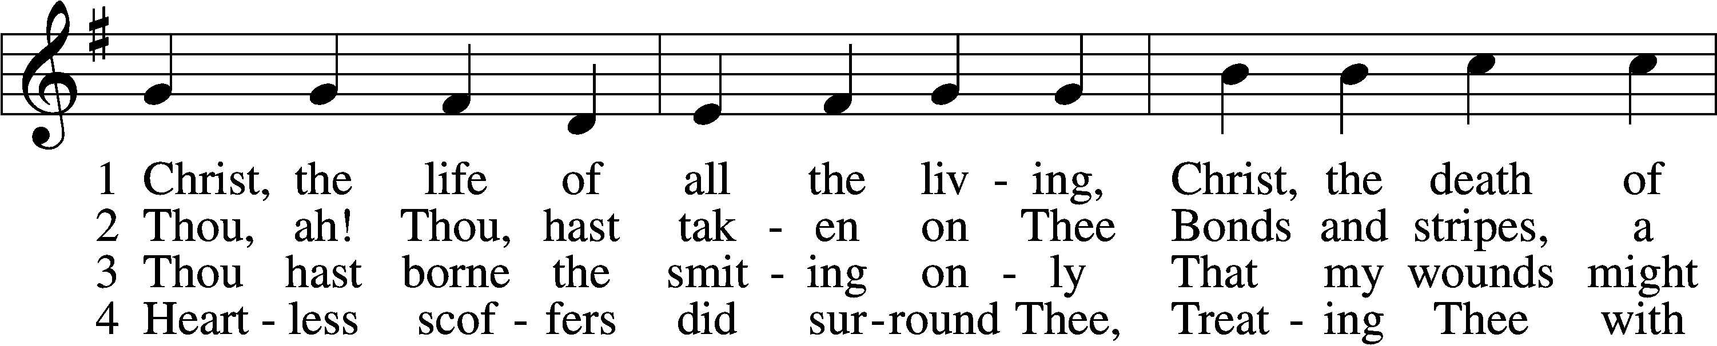

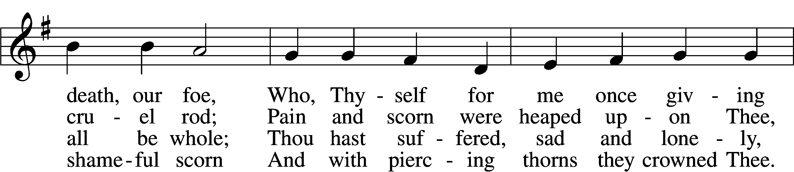

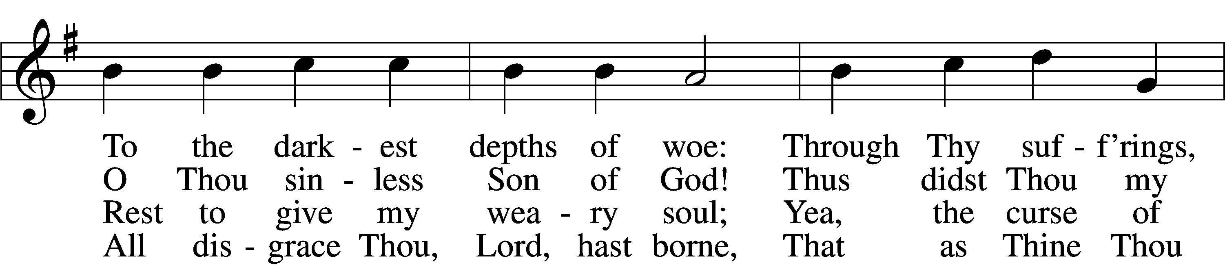

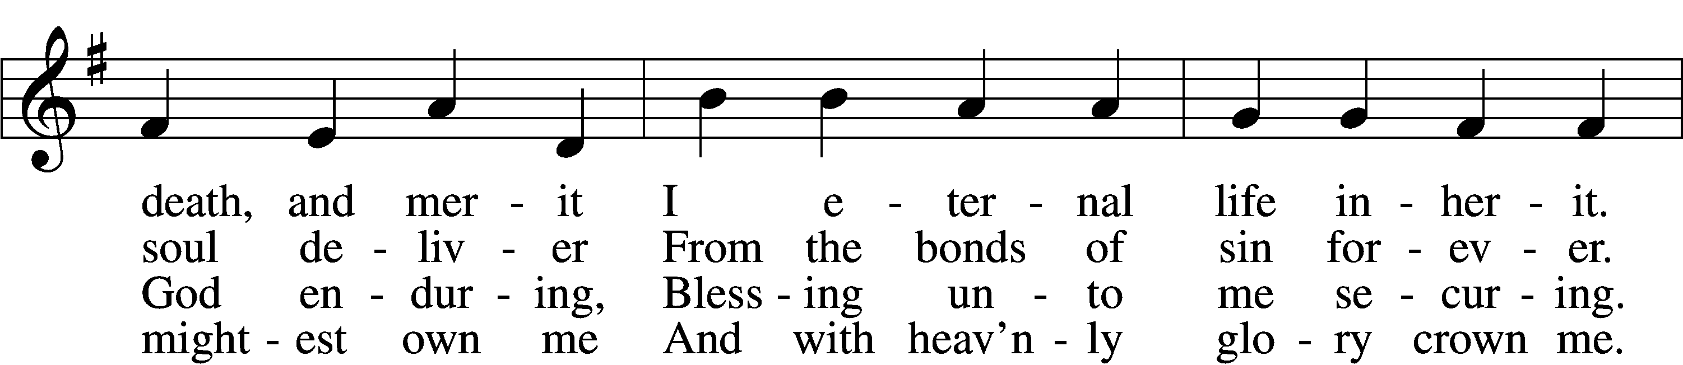

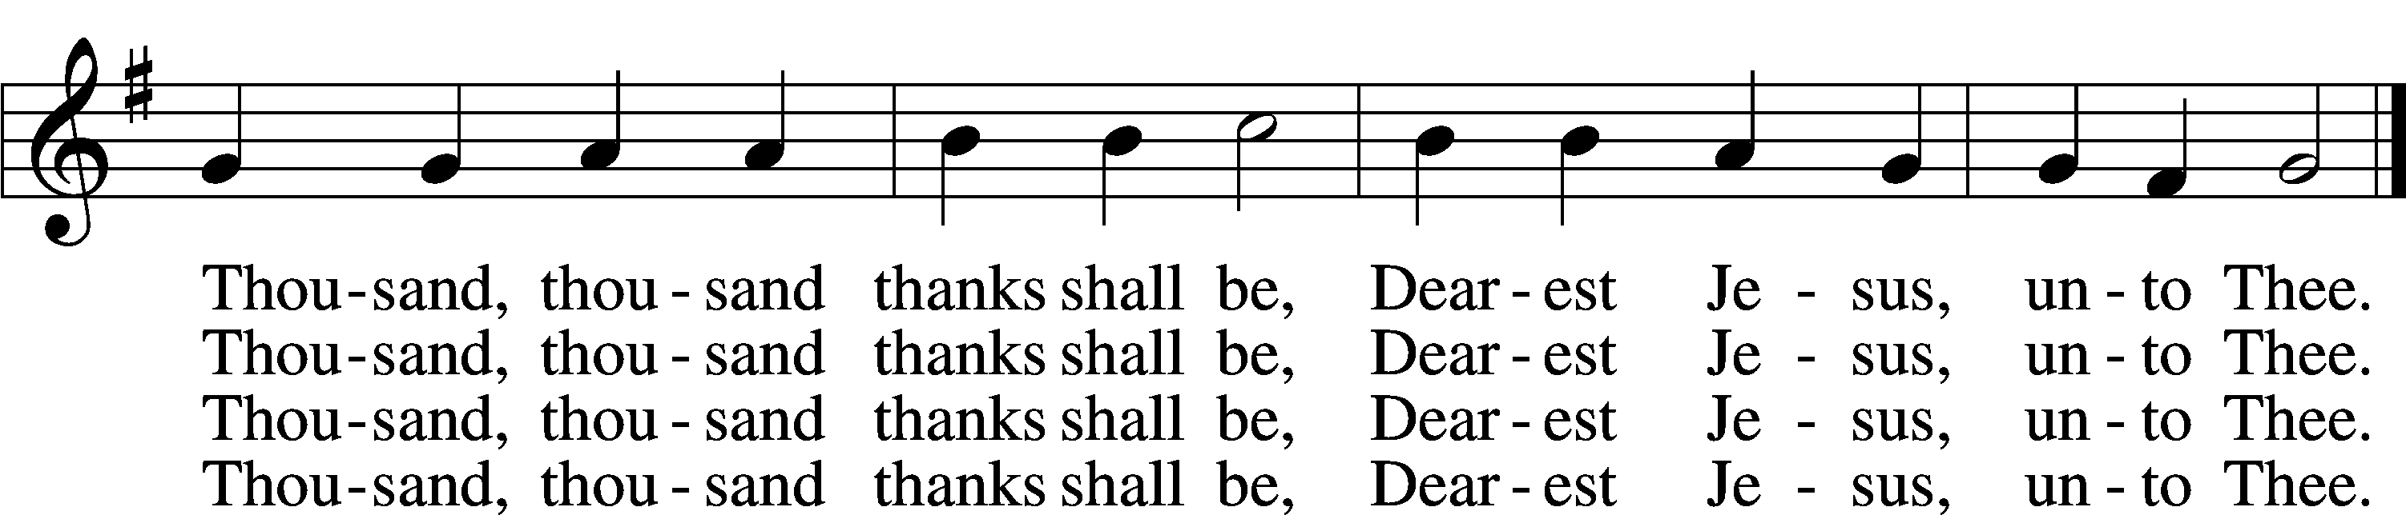

5 Thou hast suffered men to bruise Thee, That from pain I might be free;  
Falsely did Thy foes accuse Thee: Thence I gain security;  
Comfortless Thy soul did languish Me to comfort in my anguish.  
 Thousand, thousand thanks shall be, Dearest Jesus, unto Thee.

6 Thou hast suffered great affliction And hast borne it patiently,  
Even death by crucifixion, Fully to atone for me;  
Thou didst choose to be tormented That my doom should be prevented.  
 Thousand, thousand thanks shall be, Dearest Jesus, unto Thee.

7 Then, for all that wrought my pardon, For Thy sorrows deep and sore,  
For Thine anguish in the Garden, I will thank Thee evermore,  
Thank Thee for Thy groaning, sighing, For Thy bleeding and Thy dying,  
 For that last triumphant cry, And shall praise Thee, Lord, on high.

Text: Ernst Christoph Homburg, 1605–81; (sts. 1–2, 5, 7): tr. Catherine Winkworth, 1827–78, alt.; (sts. 3–4, 6): tr. Evangelical Lutheran Hymn-Book, 1912, St. Louis  
Tune: Das grosse Cantional, 1687, Darmstadt  
Text and tune: Public domain

430 My Song Is Love Unknown

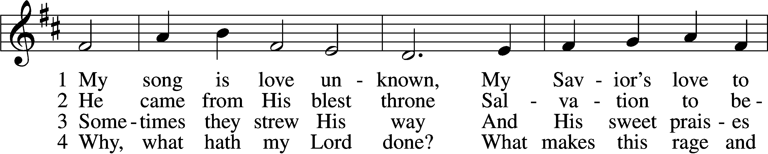

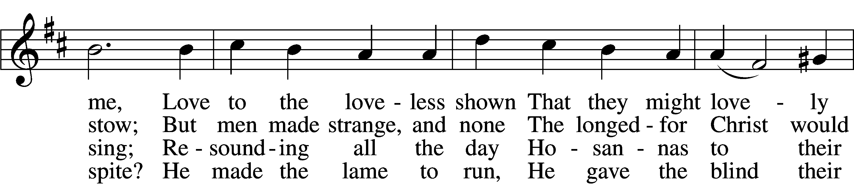

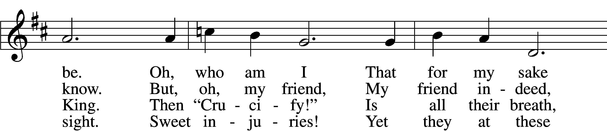

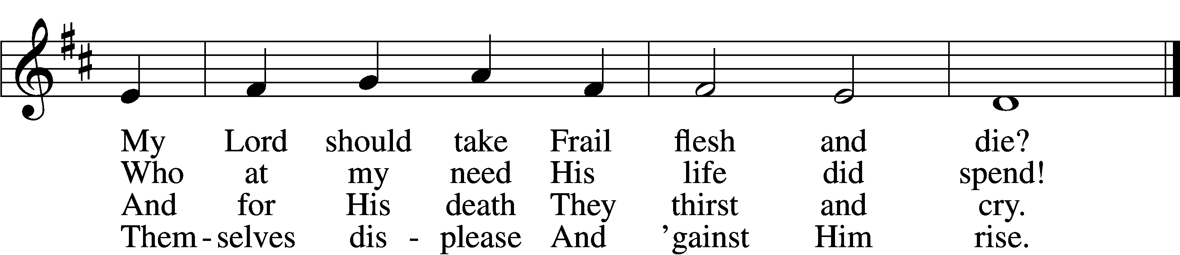

5 They rise and needs will have My dear Lord made away;  
A murderer they save,  
 The Prince of Life they slay.  
Yet cheerful He To suff’ring goes That He His foes  
From thence might free.

6 In life no house, no home My Lord on earth might have;  
In death no friendly tomb  
 But what a stranger gave.  
What may I say? Heav’n was His home But mine the tomb  
Wherein He lay.

7 Here might I stay and sing, No story so divine!  
Never was love, dear King,  
 Never was grief like Thine.  
This is my friend, In whose sweet praise I all my days  
Could gladly spend!

Text: Samuel Crossman, c. 1624–1683  
Tune: John N. Ireland, 1879–1962  
Text: Public domain  
Tune: © John Ireland Trust. Used by permission: LSB Hymn License no. 110003789

819 Sing Praise to God, the Highest Good

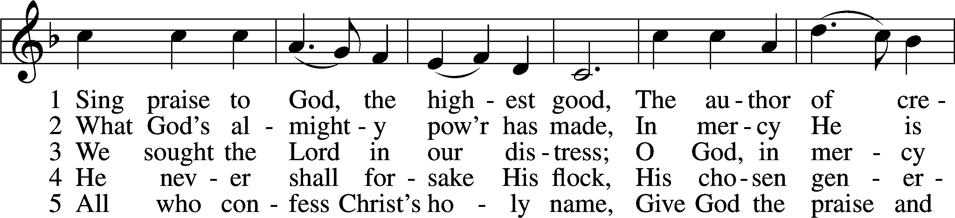

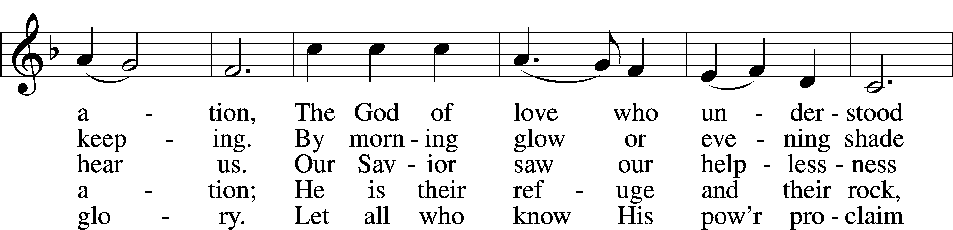

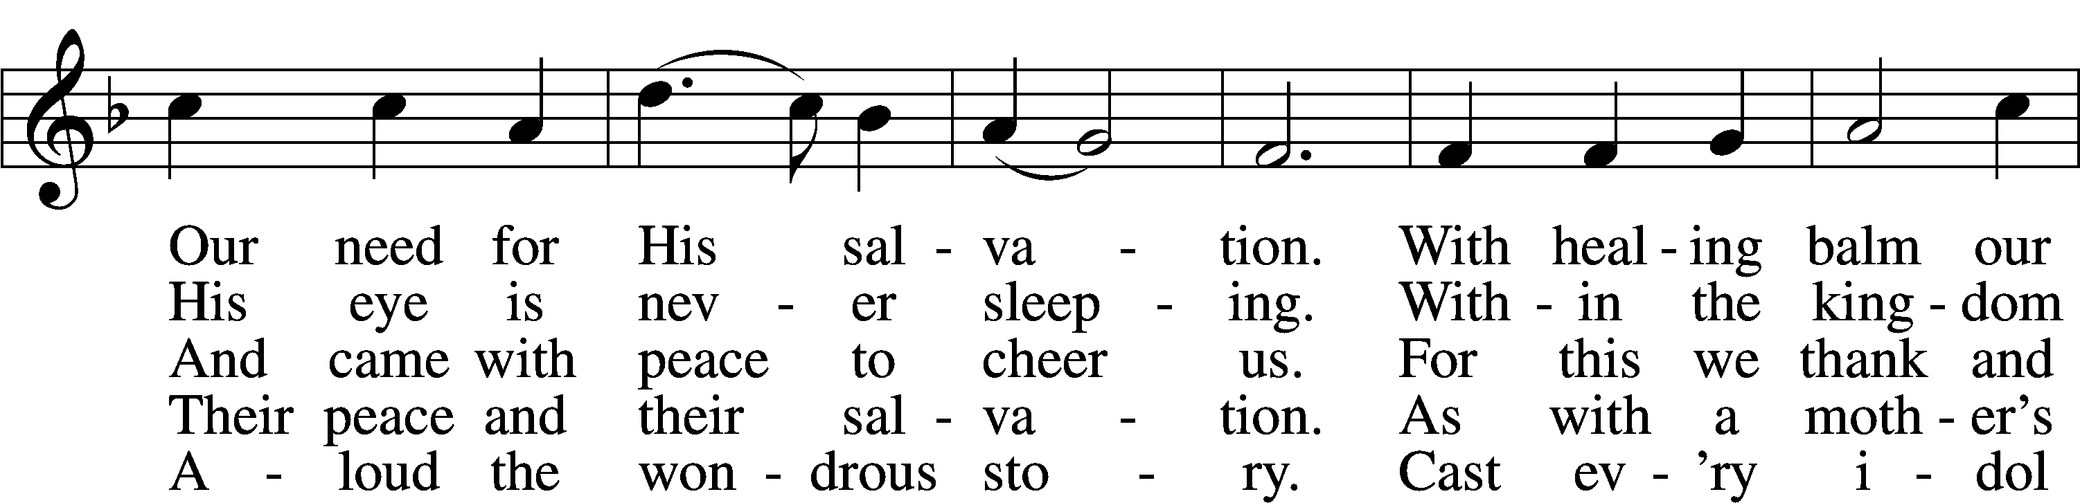

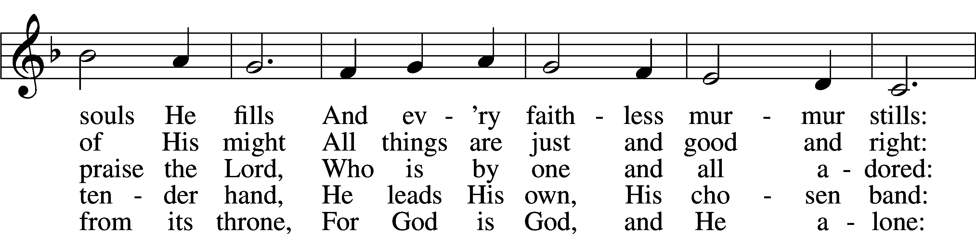

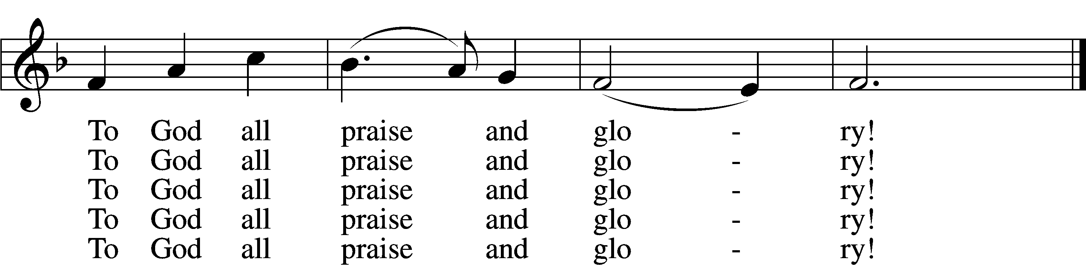

Text: Johann Jacob Schütz, 1640–90; (sts. 1–3, 5): tr. Frances E. Cox, 1812–97, adapt.; (st. 4): tr. Catherine Winkworth, 1827–78, adapt.  
Tune: Melchior Vulpius, c. 1570–1615  
Text and tune: Public domain

Stand

Nunc Dimittis LSB 199

C **Lord, now lettest Thou Thy servant depart in peace according to Thy word,**

**for mine eyes have seen Thy salvation, which Thou hast prepared before the face of all people,**

**a light to lighten the Gentiles and the glory of Thy people Israel.**

**Glory be to the Father and to the Son and to the Holy Ghost;**

**as it was in the beginning, is now, and ever shall be, world without end. Amen.**

Thanksgiving LSB 200

A O give thanks unto the Lord, for He is good,

C **and His mercy endureth forever.**

A Let us pray. We give thanks to You, almighty God, that You have refreshed us through this salutary gift, and we implore You that of Your mercy You would strengthen us through the same in faith toward You and in fervent love toward one another; through Jesus Christ, Your Son, our Lord, who lives and reigns with You and the Holy Spirit, one God, now and forever.

C **Amen.**

P The Lord be with you.

C **And with thy spirit.**

Benedicamus LSB 202

A Bless we the Lord.

C **Thanks be to God.**

Benediction LSB 202

P The Lord bless you and keep you.

The Lord make His face shine upon you and be gracious unto you.

The Lord lift up His countenance upon you and T give you peace.

C **Amen, amen, amen.**

924 Lord, Dismiss Us with Your Blessing

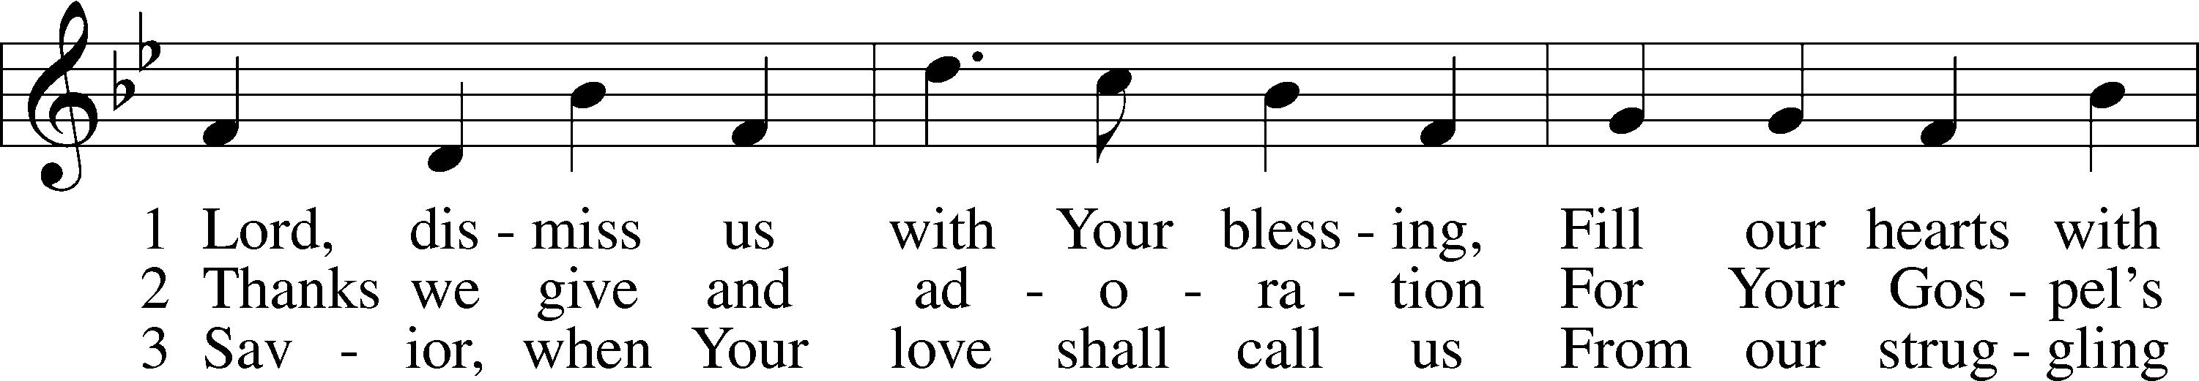

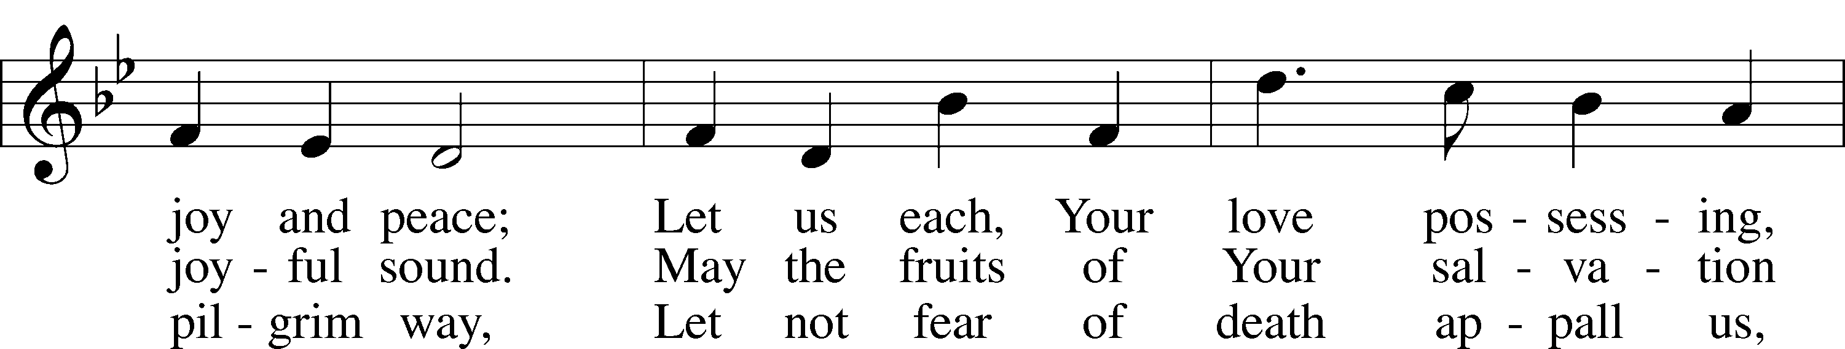

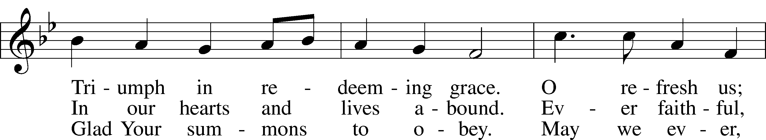

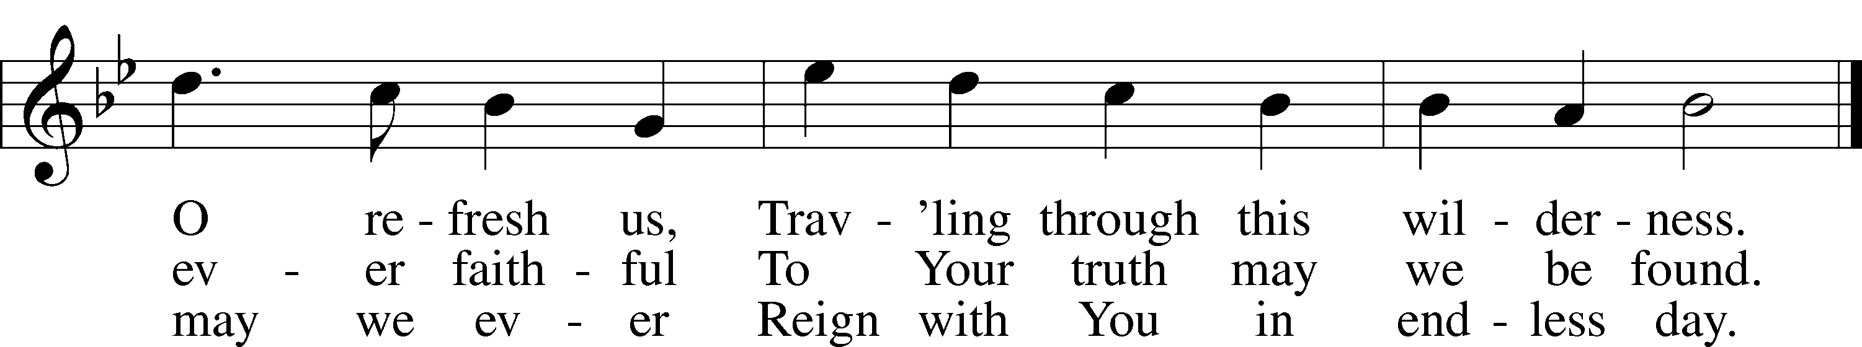

Text (sts. 1–2): attr. John Fawcett, 1740–1817, alt.; (st. 3): Godfrey Thring, 1823–1903, alt.  
Tune: Henry T. Smart, 1813–79  
Text and tune: Public domain

Acknowledgments

Divine Service, Setting Three from Lutheran Service Book

Unless otherwise indicated, Scripture quotations are from the ESV® Bible (The Holy Bible, English Standard Version®), copyright © 2001 by Crossway, a publishing ministry of Good News Publishers. Used by permission. All rights reserved.

Created by Lutheran Service Builder © 2023 Concordia Publishing House.

PRAYERS

Renee Bartlett, Allen Bures, Jay Chapin, Gail Custer, Joyce Custer, David Dawson, Delbert Grefe,

Charlie Heidbrink, Sheri Hibbert, Kandi Ingram, Toni Landenberger, Dorothy Lindquist, Jaydin Maguire, Mary Lou Meeriam, Darlene Menniga, Jim Meyer, Rhonda Meyer, Deb Minge, Stan Ohlde,

Karen Oldehoeft, Phyllis O’Toole, Dan Rash, Kaleb Rupprecht, Rick Samland, Dave Scharff,

Dorothy Scheele, Merlin Scheele, Deb Scheideler, June Snyder, Kristina Snyder, Troy Stauffer,

Janet Stuckwisch, Pastor Tim Wagner, Gene Weilage, Mary Wieters, Loretta Williams, Tyler Wolken, Tony Young

*(Loved ones are kept on the prayer list unless otherwise requested)*

**Pray for our Military:** Active Duty: Frank Lanagan, stationed in Washington;

Liam Blum, stationed in Japan

**Birthdays:** Chelsie Schlesinger, Carolyn Vitosh (03/26); Thorn Franzen (03/27);

Colton Rupprecht (03/30); Tom Penner (03/31); Lawerence Vitosh (04/01)

**Baptismal Birthdays:** Joann Scheele (03/26); Chris Hill (03/27); Krys Bures, Joe Heble, Deb Penner,

Sam Scheele, Lane Yocum (03/29)

**Anniversaries:** Ernie & Renee Hroch (03/26)

**Calendar of Events**

Sun. 03/26 9:00 am Divine Service/Communion

10:00 am Sunday School/Adult Bible Study

2:00 pm LWML Prayer Service

Wed. 03/29 3:45 pm 7th & 8th grades confirmation

4:30 pm Mid-Week for 1st-6th grades

7:00 pm Lenten Service @ Zion Harbine

Choir Practice following the service

Sun. 04/02 9:00 am Divine Service

10:00 am Sunday School/Adult Bible Study

**Worship Assistants for Sunday, March 26th**

**Greeters:** Tanner & Anne Parde & Family

**Reader:** Andy Adam **Acolyte:** Clara

**Worship Assistants for Sunday, April 2nd**

**Greeters:** Greg & Vickie Penner

**Reader:** Patty Heble **Acolyte:** Logan

**ANNOUNCEMENTS**

Monday, March 20th we began “The Chosen 3” @ 7 pm.

This will last for 8 Mondays. Please join us!

LWML Prayer Service will be today @ Our Savior, Odell @ 2:00 pm. All ladies are welcome!

The quarterly voters’ meeting will be held on Sunday, April 16th following the service. The church council will meet on Wednesday, April 5th @ 7:30 pm.

**If you would like to provide flowers in memory of a loved one on Easter, please begin thinking about it. If anyone would like to volunteer to arrange these for the church, let Pastor Stuckwisch know.**

**2 Corinthians 13:5 states: “Examine yourselves to see whether you are in the faith; test yourselves.”**

Ask yourselves**: 1.** **Are you a sinner in need of forgiveness.**

1. **Do you believe Christ’s words in the sacrament**
2. **Do you with the Holy Spirit’s help intend to change your sinful life.**

## **Confirmed members of an LCMS church or a church in fellowship with us are welcomed and encouraged to receive the Lord’s Supper**

## **Blessing at Communion**

A blessing is available to those who are not confirmed members of a LCMS Church. While children have usually been the ones to take advantage of this, it is also available to Non-LCMS adults who wish to gather at the table of our Lord with their families. Those wishing a blessing at communion are asked to cross their arms with hands on the shoulders as a signal they are not communing.